# 11 Deploying Systems

This chapter covers the following recipes:

* Building a container for a Node.js process
* Running a Docker Registry
* Storing Images on DockerHub
* Deploying a Container To Kubernetes
* Creating a deployment pipeline
* Deploying a full system
* Deploying to the Cloud

## Introduction

Deploying and operating a distributed system is a complex task. At least as complicated as creating the code for the system in the first place. Given that a significant cost of a software system involves its ongoing operation and maintenance this is certainly a skill in high demand. Before the advent of cloud and container technology this was normally accomplished through co-location of hardware within data centers. System administrators were required to have the skill in hardware, system configuration and scripting. However with the increasing adoption of cloud and container technology, the need for these lower level skills is diminishing rapidly and is largely being replaced by the role of DevOps - developers who can write code to control infrastructure and operations.

In **Chapter 10 Building Microservice Systems** we explored how decomposing a system into discrete processes and making those processes talk with each other works well with Node.js in particular, since Node is highly apt for building networked applications.

Wrapping these Node processes (microservices) in containers brings several key benefits, which is why the adoption of container technology (in general) has been so rapid across the industry:

* Encapsulation - A container holds everything that a service needs to execute, including library dependencies and environment. This solves the 'runs on my machine' problem.
* Homogeneity - If everything can be treated as a container, then we can treat all of the elements of our system in the same way.
* Orchestration - powerful container orchestration platforms are available precisely because of the encapsulated and homogeneous nature of containers

### Docker and BSD jails

The isolation model of Docker is not a new concept . The notion of processes running in an isolated environment first emerged in BSD Unix with the chroot command which evolved into the idea of isolated jails. See https://www.freebsd.org/doc/handbook/jails.html for an in-depth history.

In this chapter we will focus on deploying Node with two particular container technologies: Docker and Kubernetes. While a full introduction to these is well outside the scope of this book the following links should act as a quick start introduction to both:

* Docker overview https://docs.docker.com/engine/understanding-docker/
* Docker quick start guide https://docs.docker.com/engine/getstarted/
* Docker cheat sheet https://www.docker.com/sites/default/files/Docker_CheatSheet_08.09.2016_0.pdf
* Kubernetes overview https://kubernetes.io/docs/tutorials/kubernetes-basics/
* Kubernetes quick start guide https://kubernetes.io/docs/getting-started-guides/minikube/
* Kubernetes cheat sheet https://kubernetes.io/docs/user-guide/kubectl-cheatsheet/

In this chapter we will investigate how to build and deploy our microservice system from **Chapter 10 Building Microservice Systems** as a set of Docker containers on top of the Kubernetes platform. At a minimum, reading over Chapter 10 before proceeding would be ideal.

## Building a container for a Node.js process

In **Chapter 10 Building Microservice Systems** we developed a small microservice system.

In this recipe we're going to take the adderservice as we left it at the end of Chapter 10 in the *Adding a Queue Based Service* recipe and create a container for it.

### Getting Ready

We will be using the Docker container engine for this recipe so we should have this installed on our system. If we don't yet have this installed, we can head over to http://www.docker.com and install the appropriate binary for our system. Docker supports Linux, Windows and Mac natively.

We can check that Docker was installed successfully by opening a shell and running the following:

$ docker run hello-world

This command will pull the hello-world image from Docker Hub - a central repository of public Docker images, create a new container from that image and run it. The executable within the container will output hello from Docker along with some help text.

We also need the code from the **Chapter 10 Building Microservice Systems** available, we can get this from the source code for Chapter 10 provided with this book (source files can be obtained from the publisher website). We'll specifically be working with the source code from the *Adding a queue based service* recipe in Chapter 10.

### How to do it

Our final system from **Chapter 10 Building Microservice Systems** is depicted in below, recall that it comprises a frontend, three services and a reporting tool.

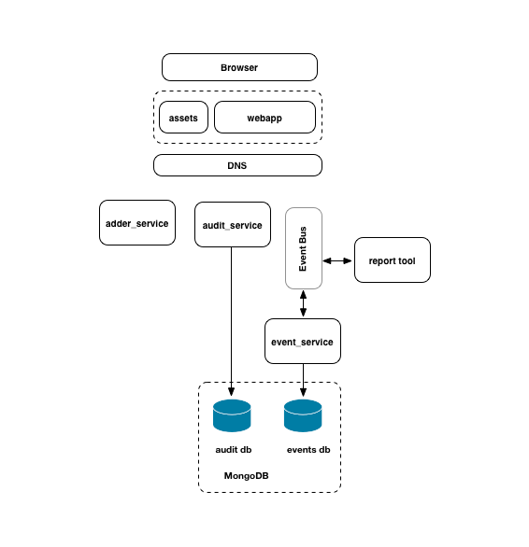

image

Our build process will need a base Docker image suitable for running Node application code. The first thing we'll do is pull an official Node base image from the Docker Hub repository.

We'll use the node:slim variant for optimal container size:

$ docker pull node:slim

### Official Node containers

There are several variants of the official node.js Docker image available. These are explained here: https://hub.docker.com/_/node/. When building a system we should select an image that best supports our use case.

Now let's build a container for the adderservice.

We'll enter the micro/adderservice directory and create two files, one called Dockerfile and the other named .dockerignore:

$ cd micro/adderservice  
$ touch Dockerfile .dockerignore

Using our favorite editor, let's place the following statements into our Dockerfile:

FROM node:slim  
RUN mkdir -p /home/node/service  
WORKDIR /home/node/service  
COPY package.json /home/node/service  
RUN npm install  
COPY . /home/node/service  
CMD [ "node", "index.js" ]

### Inspecting Official Containers

The Dockerfile for each official Docker images is publicly available on GitHub. Taking some time to inspect publicly available official Dockerfile files can furnish us with both precise knowledge of what any given container is composed of, and best practice tips for writing our own Dockerfile.

The .dockerignore file ensures that we don't add unnecessary bloat to our container, let's add the following to our .dockerignore file:

.git  
.gitignore  
node_modules  
npm-debug.log

We are now ready to build our adderservice image.

Let's run the following command from the adderservice directory:

$ docker build -t adderservice .

We should see Docker working through all of the steps in the Dockerfile to create our image.

Once the build stops we can check that our newly created container has been built by issuing the following command:

$ docker images

We should see our adderservice image in the output.

Next let's check that the image can successfully run as a container with the following:

$ docker run -e ADDERSERVICE_SERVICE_PORT=8080 -p 8080:8080 -d adderservice

Let's quickly check that our container is running correctly by using the curl command to invoke the service:

$ docker ps  
$ netstat -an | grep -i listen  
$ curl http://localhost:8080/add/2/3

We should see that the number 5 is returned from the service.

We can now close down any running containers with the following:

$ docker kill $(docker ps -q)

We have just built and run our first microservice container!

### How it works

Containers provide an isolated environment for our application and service code to execute in. The Dockerfile defines exactly what should go into this environment. Typically this should include all of the library and environmental dependencies that our code requires to execute successfully.

Let's analyze what we placed into this container.

The Dockerfile contained the following instructions:

FROM node:slim  
RUN mkdir -p /home/node/service  
WORKDIR /home/node/service  
COPY package.json /home/node/service  
RUN npm install  
COPY . /home/node/service  
CMD [ "node", "index.js" ]

Let's examine these statements line-by-line:

* FROM node:slim - instructs Docker's build process to use node:slim as the base container image. This means that Docker will modify the node:slim image based on our instruction set to create the new service image.
* RUN mkdir -p /home/node/service - will run the mkdir command to create the directory /home/node/services. It is important to understand that and RUN commands execute in the context of the container. In other words this directory will be created inside the container not on the machine that is running the build.
* WORKDIR /home/node/service - sets the working directory for all future RUN and COPY commands in this Dockerfile
* COPY package.json /home/node/service - copies the package.json file from the build machine to the /home/node/service inside the container
* RUN npm install - runs npm install inside the container using the dependencies as listed in our package.json file. As a rule of thumb, we shouldn't just copy across our node_modules folder (unless we are sure there are no native dependencies and never will be). This is because the execution environment within the container may be different to our build system so any binary dependencies need to be installed from scratch.
* COPY . /home/node/service - copies our application code into the container. Note that the copy command will ignore all patterns listed in our .dockerignore file. This means that the COPY command will not copy node_modules and other information to the container.
* CMD [ "node", "index.js" ] - specifies the default command to execute when starting the container. This command will execute in the /home/node/service directory. The syntax for creating the command actually matches how process.argv parses command line inputs.

### Binary incompatibility

It is important to stress avoiding the shortcut of copying the node_modules folder into a container, as a general rule. This is because some modules contain binary dependencies that will be built for the host system. Instead running npm install from the Dockerfile will ensure that the correct binaries are placed inside our container. Failing to do this can result in some difficult to fix bugs! What's more, by copying the package.json first, then running npm install, and only after that copying our source code we're taking advantage of Dockers layer caching system. The upshot is, if we rebuild our container the npm install will *only* run again if the package.json file was modified. This makes the copying of the node_modules folder less compelling from a build time perspective, since it would be faster to use Dockers cache.

The Docker build process created an image which we should have seen in the docker images command output.

We created and executed a container from the image using the docker run command:

$ docker run -e ADDERSERVICE_SERVICE_PORT=8080 -p 8080:8080 -d adderservice

Let's explore the flags we passed to the docker run command:

* -e specifies an environment variable to set when running the container. In this case the ADDERSERVICE_SERVICE_PORT. The environment variable is read in the adderservice code and used to bind to the specified port number.
* -p exposes a port from the container to the host system (the machine which is running docker). Inside the container our service code is listening on port 8080, however in order for us to 'see' the service from outside of the container we need to tell Docker to expose this port for us.
* -d instructs Docker to run this container in the background as a daemon process.

### There's more

Each command in the Dockerfile potentially creates a new layer in the image. This allows container deployment to be very efficient. For example if we subsequently change some code in our service and rebuild the container, this will result in a very thin layer being created that represents just the delta between the last image and this one.

This means that if our target deployment environment has all of the previous layers, deployment of a new version of a container may only require a new layer of a few kilobytes or less.

Let's explore Docker layers.

#### Viewing the layers in a Docker image

It is possible to view the layers that make up an image using the docker history command.

Let's try it:

$ docker history adderservice

This should output something similar to the following image:

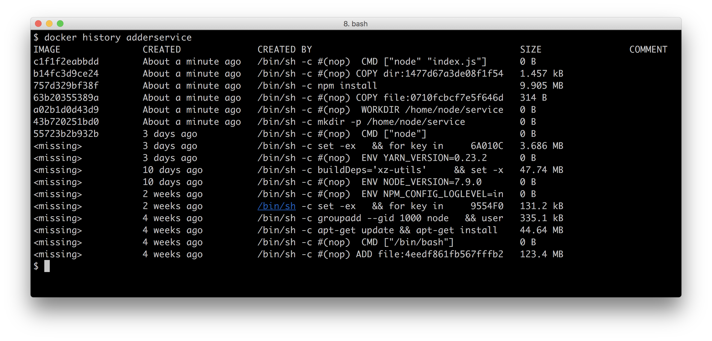

image

Not only does this command show the layers created by our Dockerfile, it also shows the commands that were used to build up the base image, in this case our base node:slim image.

#### Adding a new layer

To see how Docker adds layers to an image let's make a change to the adder service and rebuild the container.

For example we could modify our adderservice/index.js like so:

console.log('HI!')  
const wiring = require('./wiring')  
const service = require('./service')()  
  
wiring(service)

Then we can rebuild the container with:

$ docker build -t adderservice .

Let's see how that's affected the images by running:

$ docker images

The output would look something like the following:

REPOSITORY TAG IMAGE ID CREATED SIZE  
adderservice latest 7809fbfaaf33 3 seconds ago 226 MB  
<none> <none> 83c1f429d9c5 13 minutes ago 226 MB  
node slim 9be176e26d04 3 weeks ago 216 MB

Notice the image labeled <none>. This is the previous version of our adderservice container which was displaced because we built another image with the same tag name. The second build command has moved the repository name and the latest tag to our new image.

If we now rerun the history command, like so:

$ docker history adderservice

We should be able to see how our layers have changed, as in the following figure:

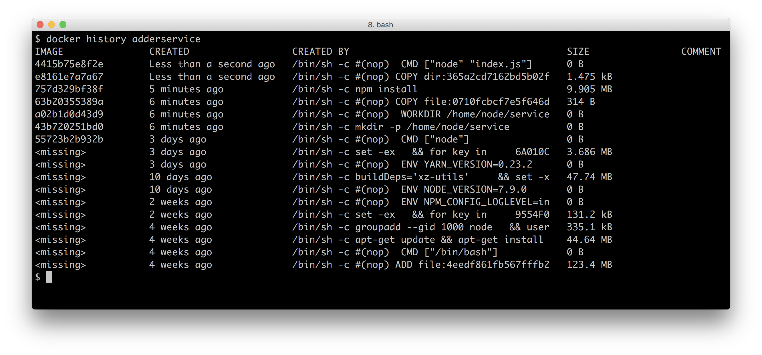

image

If we look at the IMAGE column, we can see that the ID for the uppermost two layers is different. This means that the difference between these two images is just these two layers. Notice also that these layers consist of a total of 1.475 kBytes. It is important to understand that when this change to a container is deployed, on the delta, in this case only 1.475 kBytes will be changed.

#### Docker alternatives & container standards

Docker is the leading container technology at present. However it should be pointed out that alternatives do exist. One such alternative is the rkt engine which is part of the CoreOS project. we can find out more about rkt here: https://coreos.com/rkt/.

Following the recent explosive growth in container technology, there has been a drive to push for binary and runtime standardization among interested parties in this space. The standardization effort is being led by the Open Container Initiative, we can read about their work here: https://www.opencontainers.org/

### See also

* *Adding a Queue Based Service* in **Chapter 10 Building Microservice Systems**
* *Deploying a Container to Kubernetes* in this chapter
* *Storing Images on DockerHub* in this chapter
* *Running a Docker Registry* in this chapter

## Running a Docker Registry

In this recipe we are going to publish our adderservice container that we built in the last recipe to our own private Docker registry.

### Getting Ready

To get setup for this recipe we need to pull the official Docker registry container.

We do this by running the following:

$ docker pull registry

This recipe uses the code from the previous recipe *Building a container for a Node.js process*.

If we haven't already done so, we'll need to build the the adderservice image from the previous recipe:

$ cd micro/adderservice  
$ docker build -t adderservice .

Finally we need the openssl command line tool available, which should be installed with our preferred package manager (for example homebrew if we are using a Mac).

### How to do it

Let's start a Docker registry container (we pulled the Docker registry container in the *Getting Ready* section of this recipe) with the following command:

$ docker run -d -p 5000:5000 --name registry registry:2

If we now issue a docker ps command we can see that our registry container is up and running on port 5000.

Now let's push a container to the registry to test it out.

To do this we need to tag an image with a specific naming convention.

Let's run the following command:

$ docker tag adderservice localhost:5000/adderservice

If we now issue a docker images command we should see the tag against our adderservice image:

REPOSITORY TAG IMAGE ID CREATED SIZE  
adderservice latest ced38dc8a822 2 hours ago 235 MB  
localhost:5000/adderservice latest ced38dc8a822 2 hours ago 235 MB

We can now push the image to our local registry:

$ docker push localhost:5000/adderservice

We can check that this was successful by pulling the image back again:

$ docker pull localhost:5000/adderservice

Running a registry in this configuration is not all that useful because the registry is only accessible over the localhost interface.

To run a registry in production we should use a full domain registry which requires a domain certificate.

However to run a local development registry, say for our development teams office, we can use a self signed certificate.

Let's use the openssl tool to create a self signed certificate:

$ cd micro  
$ mkdir certs  
$ openssl req -newkey rsa:4096 -nodes -sha256 -keyout \  
 certs/localhost.key -x509 -days 365 -out certs/localhost.crt

Before we can generate the certificate openssl will ask some questions. For most we can simply press return. However the Common Name prompt should be passed "localhost" as the response:

Common Name (e.g. server FQDN or our name) []:localhost

Now that we have generated our certificate we need to tell Docker about it.

To do this on Mac we run the following:

$ sudo security add-trusted-cert -d -r trustRoot -k /Library/Keychains/System.keychain certs/localhost.crt

On Linux the command would be:

$ sudo cp certs/localhost.crt /etc/docker/certs.d/localhost:5000/ca.crt

#### Linux troubleshooting

Some Linux distributions require other steps to allow Docker to use a self signed certificate, see https://docs.docker.com/registry/insecure/#troubleshooting-insecure-registry

On Windows (assuming the ProgramData directory is at C:\ProgramData) we'd add our certificate with:

$ copy certs\localhost.crt C:\ProgramData\docker\certs.d\localhost5000\ca.crt

We now need to restart Docker to allow the daemon to pick up the certificate. Once Docker has restarted we can spin up our registry container passing the certificate configuration via the necessary environment variables:

$ cd micro  
$ docker run -d -p 5000:5000 --name registry -v `pwd`/certs:/certs \  
 -e REGISTRY_HTTP_TLS_CERTIFICATE=/certs/localhost.crt \  
 -e REGISTRY_HTTP_TLS_KEY=/certs/localhost.key registry:2

Finally we can tag and push our adderservice image to our secured registry:

$ docker tag adderservice localhost:5000/adderservice  
$ docker push localhost:5000/adderservice

### Querying private registries

Whist there is currently no official command line client to query the contents of a Docker registry we can interface directly to the the registry HTTP API. For instance curl https://localhost:5000/v2/_catalog will return a list of all images in the local private registry in JSON format.

In order to pull and push images from other machines - for example other developers in our team, we can simply share the generated certificate file.

### How it works

We use openssl to create a self signed certificate. This basically means we are our own Certificate Authority, we give credence to the certificate. The CRT file doubles as both the certificate authority key and the private key in a typical SSL exchange.

We register the certificate file Docker by copying it to a relevant folder or registering it with Keychain in the case of Mac. Then we start our Docker registry container, and mount our certs folder into the container using the -v flag. This effectively means our certs folder is a shared folder - between the host machine and the container.

Then we set two environment variables with the -e flag which configure the registry to use the relevant key and certificate files in the mounted /certs folder.

It should be noted that using a self signed certificate is fine within a development setting, for sharing images across a development team, as access to the certificate can be tightly controlled. However a full domain registry or a hosted registry must be used in any deployment environment.

### Domain Registry

Instructions on how to run a secured domain registry can be found here https://docs.docker.com/registry/deploying/

Docker tagging may seem a little confusing at first so let's dig into the details a little.

A tag is comprised of the following:

[registry host[:registry port]/]image name[:version]

In other words the registry host, port and version part of the tag are optional. If no registry name is supplied then any subsequent push command will attempt to push to the central Docker hub which can be accessed at https://hub.docker.com/. Indeed once we have signed up for an account we may push and pull to this registry.

### Registry and Repository

We may hear the term repository and registry used interchangeably with regard to Docker. Strictly speaking registry refers to a Docker registry server such as the private registry that we ran in the last recipe or the central Docker hub. A repository refers to a collection of images, for example, we could create an account on the Docker Hub, create a repository against this account and then push images into this repository.

Once an image has been tagged with a repository, the docker push command can be used to push images to that repository. We should emphasize that we're using an insecure local private registry, which is fine for experimentation. However in a full production environment a secured registry should always be used even when sitting behind multiple firewall layers.

We have been running the official Docker registry container however there are alternatives to this that we can install and run on premise:

#### Registry alternatives

We've been running the official Docker registry, which is freely available. Additional enterprise alternatives include the CoreOS Enterprise Registry and Artifactory from JFrog also offers Container artifact management.

### There's more

Let's explore Docker tags a little more.

#### Tagging

Let's look again at the output of the docker images command:

REPOSITORY TAG IMAGE ID CREATED SIZE  
192.168.1.2:5000/adderservice latest ba4c0f31a321 34 minutes ago 226 MB  
adderservice latest ba4c0f31a321 34 minutes ago 226 MB  
192.168.1.2:5000/report latest e4331baa0d97 35 minutes ago 219 MB  
report latest e4331baa0d97 35 minutes ago 219 MB  
192.168.1.2:5000/webapp latest bb760b8d806a 36 minutes ago 233 MB  
webapp latest bb760b8d806a 36 minutes ago 233 MB  
192.168.1.2:5000/eventservice latest f3ee71045a1b 36 minutes ago 223 MB  
eventservice latest f3ee71045a1b 36 minutes ago 223 MB  
192.168.1.2:5000/auditservice latest f88358133c8e 36 minutes ago 232 MB  
auditservice latest f88358133c8e 36 minutes ago 232 MB

Note that the TAG field for our containers is 'latest'. This is the version tag that is applied in the case that an explicit version tag is not specified. Docker will move the 'latest' tag for us when we change, build and tag containers. To see this make a change to one of the files in the adderservice by adding a comment or a console.log and rerun the build script. The output should be similar to the following:

REPOSITORY TAG IMAGE ID CREATED SIZE  
192.168.1.2:5000/adderservice latest d33f02b95f74 31 minutes ago 226 MB  
adderservice latest d33f02b95f74 31 minutes ago 226 MB  
192.168.1.2:5000/adderservice <none> ba4c0f31a321 34 minutes ago 226 MB  
192.168.1.2:5000/report latest e4331baa0d97 35 minutes ago 219 MB  
report latest e4331baa0d97 35 minutes ago 219 MB  
192.168.1.2:5000/webapp latest bb760b8d806a 36 minutes ago 233 MB  
webapp latest bb760b8d806a 36 minutes ago 233 MB  
192.168.1.2:5000/eventservice latest f3ee71045a1b 36 minutes ago 223 MB  
eventservice latest f3ee71045a1b 36 minutes ago 223 MB  
192.168.1.2:5000/auditservice latest f88358133c8e 36 minutes ago 232 MB  
auditservice latest f88358133c8e 36 minutes ago 232 MB

We can observe that the latest tag has been moved for the changed service. For experimentation it's fine to use the latest tag however for a full production system it is best to explicitly apply a version tag to our containers.

### See also

* *Adding a Queue Based Service* in **Chapter 10 Building Microservice Systems**
* *Building a container for a Node.js process* in this chapter
* *Storing Images on DockerHub* in this chapter

## Storing Images on DockerHub

DockerHub provides a global repository of images. In **Chapter 10 Building Microservice Systems** we implicitly used the global repository when we pulled MongoDB and Redis images. We also made use of it in the previous recipe *Building a container for a Node.js process* when we fetched the Docker Registry container.

In this recipe we are going to push our adderservice container to DockerHub.

### Getting Ready

This recipe uses the code from the first recipe in this Chapter, *Building a container for a Node.js process*.

If we haven't already done so, we'll need to build the adderservice image:

$ cd micro/adderservice  
$ docker build -t adderservice .

### How to do it

Firstly we need to create an account on DockerHub, to do this head over to http://hub.docker.com and sign up for an account:

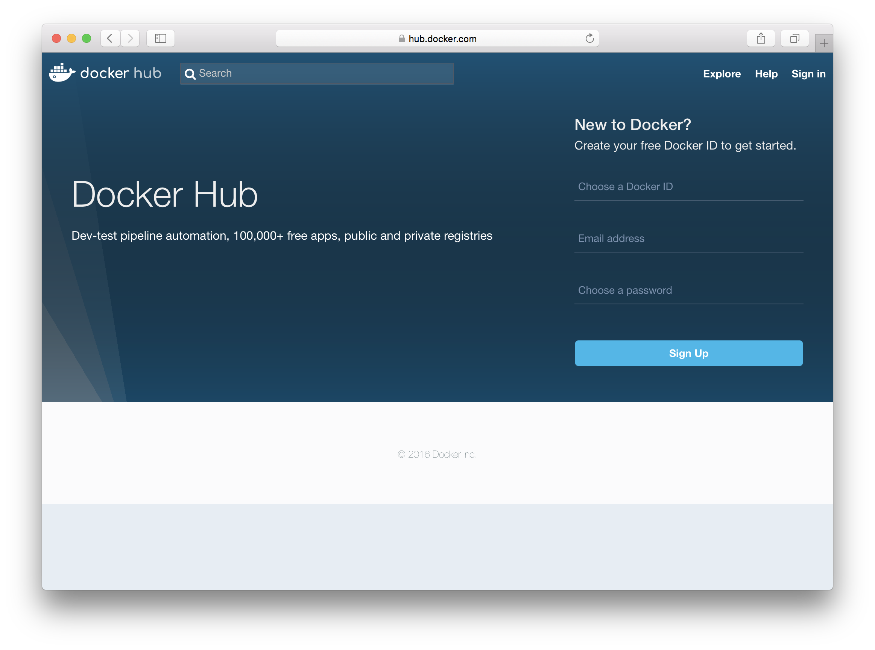

image

Once we have our account we need to create a repository for our adderservice images. To do this hit the Create Repositoy button as illustrated below:

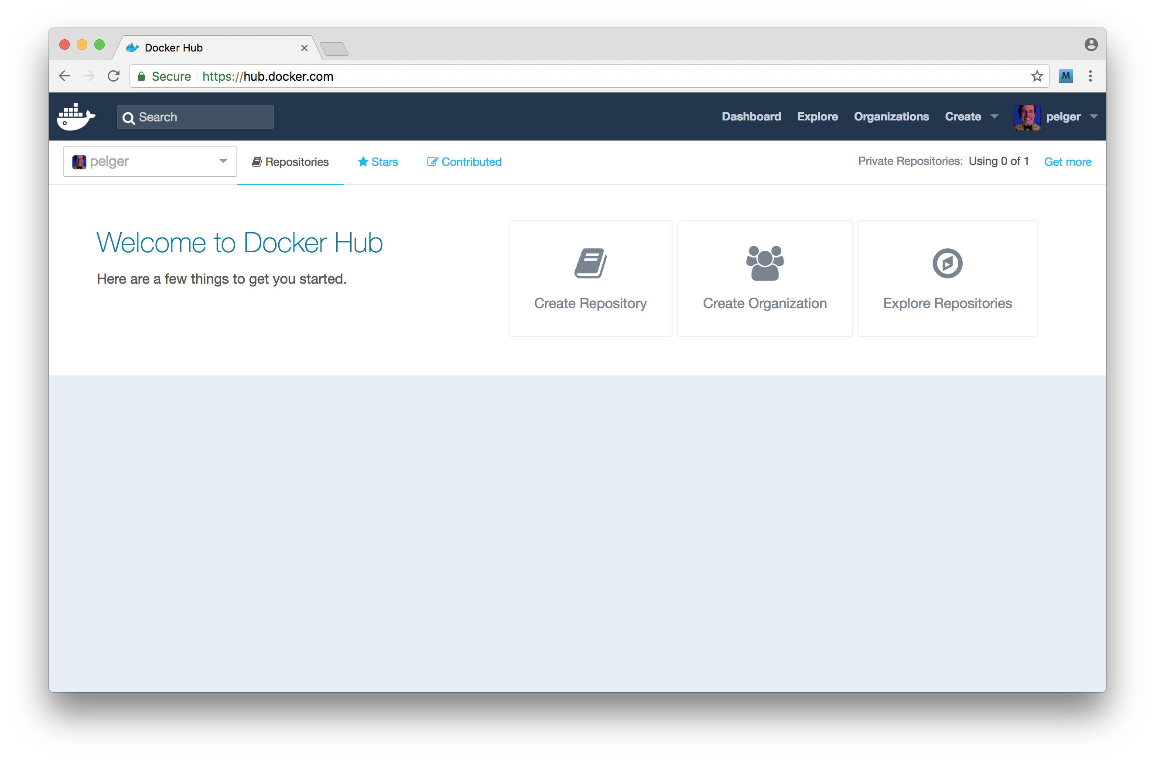

image

We need to complete the form using adderservice as the repository name, leaving the "Visibility" of the repository as "public".

Once the repository is created we should see a screen similar to the following:

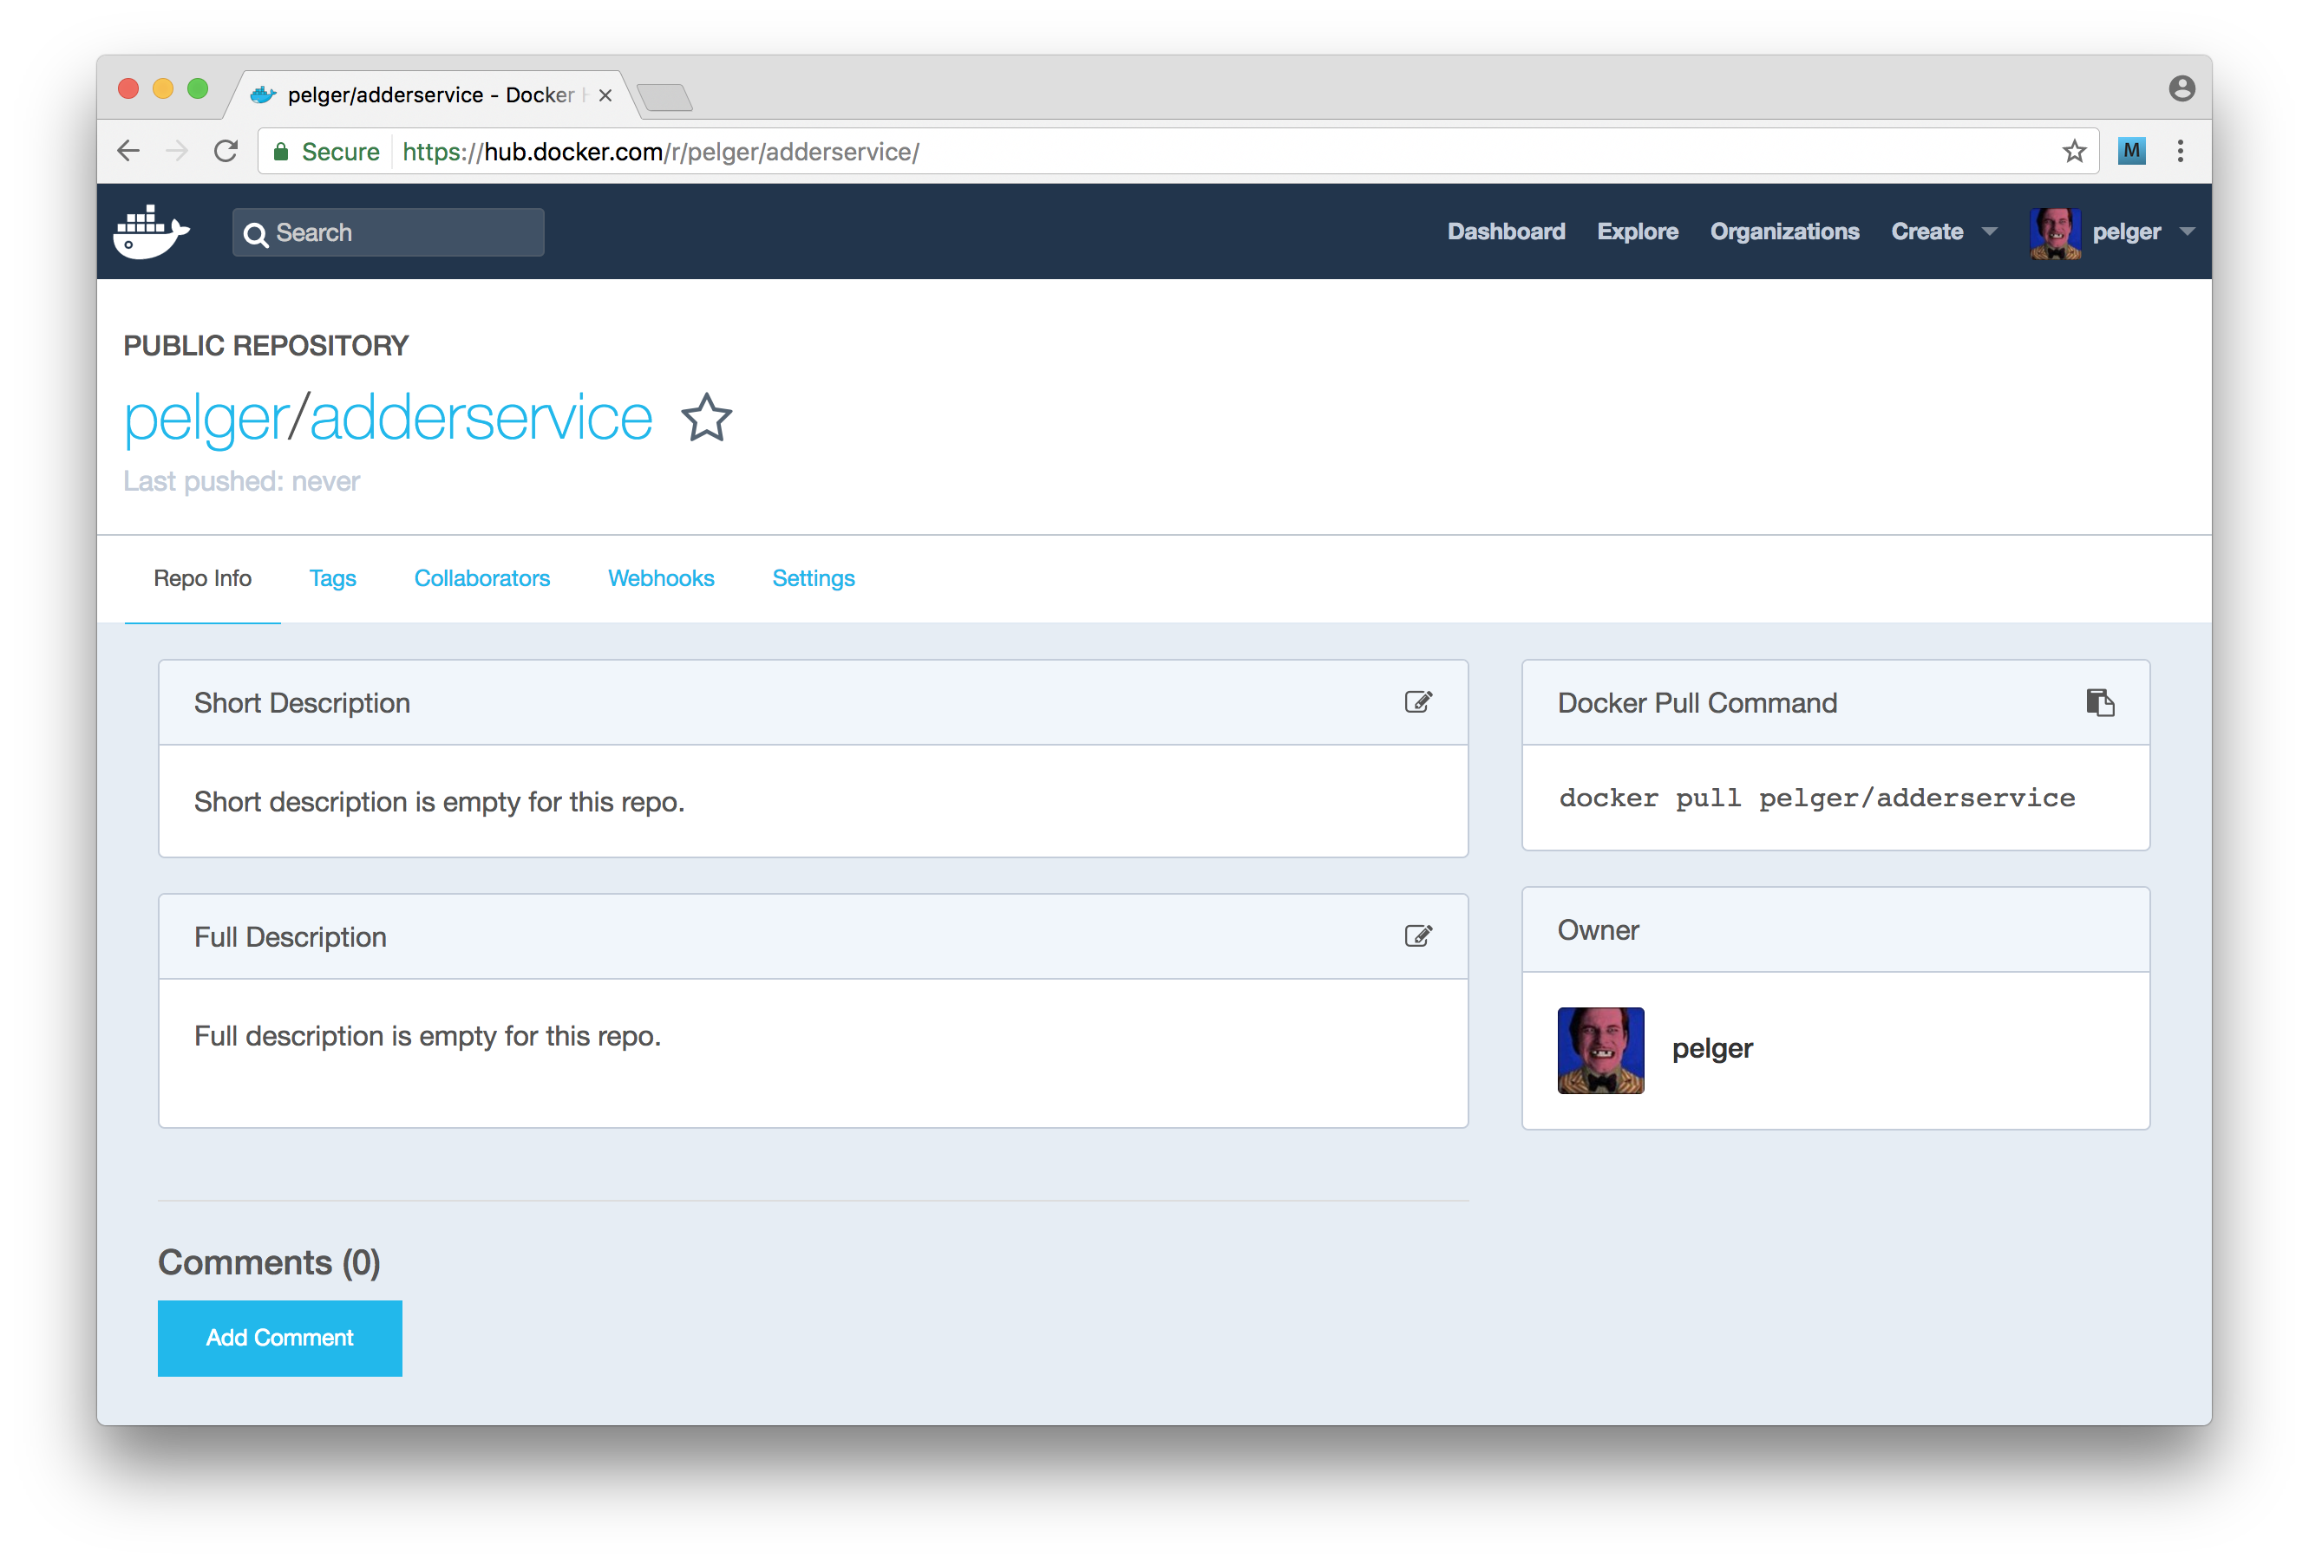

image

Of course the username will be different in each case!

Now that we have our account setup we need to login from our Docker command line client, to do this run:

$ docker login

Once we have logged in, we can push our adderservice image to DockerHub.

As in the previous recipe we need to tag the image and then push by running the following commands:

$ docker tag adderservice <namepace>/adderservice  
$ docker push <namespace>/adderservice

Replacing <namespace> with the repository namespace, which is to say the docker hub account name (in the illustrated case the namespace is pelger).

Docker will push our image to the hub.

We can navigate to the tags tab to confirm that the push was succesful, as illustrated below:

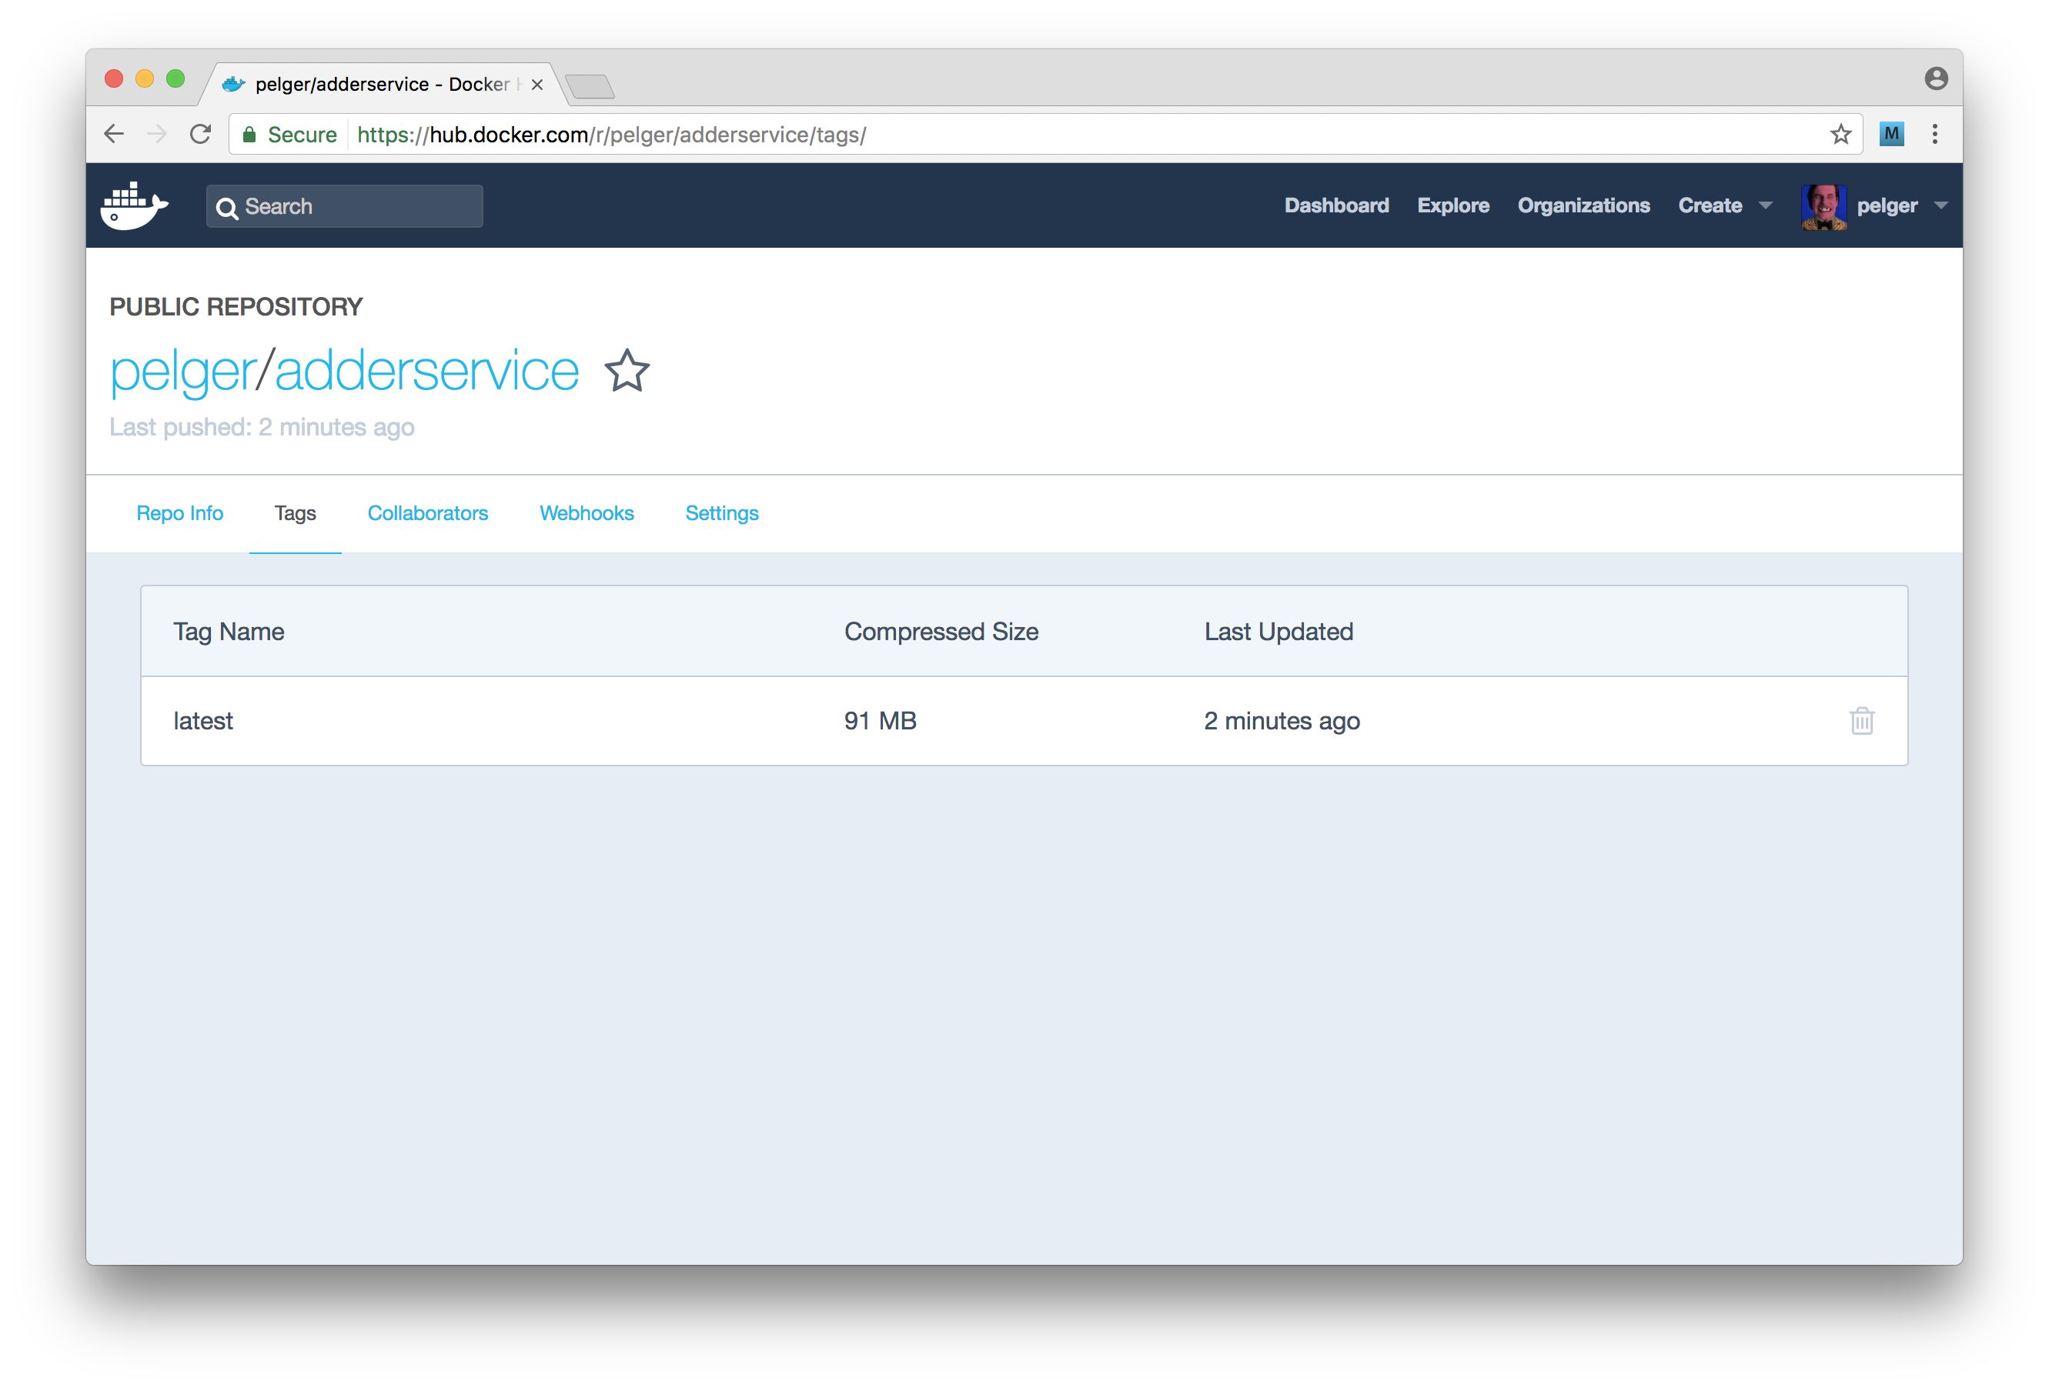

image

We should also now be able pull this image:

$ docker pull <namespace>/adderservice

### How it works

Applying the tag <namespace>/adderservice instructs Docker that this image is associated with a repository on DockerHub. Docker differentiates between a local private registry and the central hub based on the format of the tag. If the namespace tag contains an IP address or dotted domain name and port then Docker will attempt to push/pull from a private registry. If the tag is just a namespace then Docker will use the central Hub to push and pull. To minimize confusion the namespace that we provide on DockerHub is restricted to only allow letters and digits.

In this recipe we created a public repository. DockerHub is free to use for public repositories, but of course public repositories may be accessed by anyone on the internet. This is a similar model to GitHub and other cloud-based code version management systems. It's therefore important not to push any proprietary code or secret information (such as ssh or API keys) to a public repository.

It is possible to host private repositories on DockerHub for a fee. Private repositories are only accessible to nominated DockerHub accounts so access can be tightly controlled.

DockerHub is just one of several cloud based registries that we can use, alternatives include:

* Google Container Registry - managed registry for those using Google cloud services
* Amazon ECR - managed registry for those using AWS

### There's more

Using a cloud based registry can be far more convenient than managing our own on-premise registry. However a proficient image version management strategy is imperative. Let's explore image versioning.

#### Using a specific version tag

Applying the tag structure in this recipe results in Docker applying using latest as the version tag. When we build a new version of an image without explicitly providing a version, Docker will move the latest tag to this new image and leave the previous build untagged. The same process will occur with images that we push to Docker Hub. It is generally better practice to use a specific image version tag. By doing this we can maintain a history of our images which makes any rollback or post incident analysis easier.

Let's tag our adderservice image with a version by running:

$ docker tag adderservice <namespace>/adderservice:1

We can now push this image to Docker Hub, like so:

$ docker push <namespace>/adderservice:1

If we now navigate to the Tags panel for our adderservice image on DockerHub we can see that our newly pushed image is available.

Using an incremental build number is one approach to maintaining version tags, another approach is to pull the version field from package.json and use that as a version tag. Our preferred approach is to use the git SHA as a version tag, that we we can immediately identify the exact code that is built into our service containers.

### See also

* *Adding a Queue Based Service* in **Chapter 10 Building Microservice Systems**
* *Using containerized infrastructure* in **Chapter 10 Building Microservice Systems**
* *Building a container for a Node.js process* in this chapter
* *Storing Images on DockerHub* in this chapter
* *Deploying a Container to Kubernetes* in this chapter

## Deploying a Container to Kubernetes

Kubernetes is an open source container orchestration and management system originally built at Google. Kubernetes is a powerful tool and can become quite complex. However the basics are fairly simple to understand. To get to grips with Kubernetes, we will be deploying a single container into a local Kunbernetes system using Minikube. Minikube is a convenient way to explore the power of Kubernetes without building a complex cloud based deployment.

### Getting ready

For this recipe we will need to install Minikube locally. Let's head over to the project's GitHub page at https://github.com/kubernetes/minikube/releases to install prerequisites and the appropriate build for our platform.

This recipe builds on the work that we did in the recipe *Storing Images on DockerHub*, in order to proceed with the recipe we will need a DockerHub account with our adderservice container available.

We will also need the code from our first recipe in this chapter, *Building a container for a Node.js process*.

Once we have our code, a DockerHub account and Minikube installed we are good to go.

### How to do it

Firstly we need to start up minikube. To do so, we can execute the following:

$ minikube start

Now that we have Minikube running let's try out a few commands.

The main interface into Kubernetes is the kubectl command line tool, which was installed during the Minikube installation process.

Let's confirm that kubectl was installed successfully:

$ kubectl version

$ kubectl help

We should see the version of Kubernetes that we are running and then some help information.

Let's try some commands to list out the current state of our local Kubernetes cluster:

$ kubectl get nodes

$ kubectl get services

We should see that we have a single node in the cluster and a single Kubernetes service running. Let's now go ahead and deploy our adderservice.

Let's begin by creating a deployment directory inside our micro folder,with three configuration files namespace.yml, adderservice-dep.yml and adderservice-svc.yml:

$ cd micro  
$ mkdir deployment  
$ cd deployment  
$ touch namespace.yml adderservice-dep.yml adderservice-svc.yml

Recall from the *Service discovery with DNS* recipe in **Chapter 10 Building Microservice Systems** that we used the DNS namespace micro, we need to create a namespace in Kubernetes to mirror our present DNS configuation. Fortunately, this is fairly trivial to achieve.

Let's add the following to deployment/namespace.yml:

apiVersion: v1  
kind: Namespace  
metadata:  
 name: micro  
 labels:  
 name: micro

Next we register the namespace decribed with Kubernetes like so:

$ kubectl create -f namespace.yml

Now that we have our namespace created we need to set the Kubernetes context to use this namespace as the default. Meaning that all subsequent kubectl operations will use the micro namespace as opposed to the default namespace.

To enable this let's run:

$ kubectl config set-context minikube --namespace=micro

Next let's describe the deployment topology by adding the following code to the adderservice-dep.yml file:

apiVersion: extensions/v1beta1  
kind: Deployment  
metadata:  
 name: adderservice  
spec:  
 replicas: 1  
 template:  
 metadata:  
 labels:  
 run: adderservice  
 spec:  
 containers:  
 - name: adderservice  
 image: <dockerhub-account>/adderservice  
 ports:  
 - containerPort: 8080

In doing this we need to replace <dockerhub-account> with the account namespace that we used to upload our adderservice to DockerHub in the previous recipe.

We also need to supply Kubnerenets with service description to allow adderservice container to be exposed to the deployment.

Let's populate adderservice-svc.yml with the following configuration code:

apiVersion: v1  
kind: Service  
metadata:  
 name: adderservice  
 labels:  
 run: adderservice  
spec:  
 ports:  
 - port: 8080  
 name: main  
 protocol: TCP  
 targetPort: 8080  
 selector:  
 run: adderservice  
 type: NodePort

Now let's actually push the button and deploy our adderservice container.

Run the following two commands:

$ kubectl create -f adderservice-svc  
$ kubectl create -f adderservice-dep

Kubernetes will begin rolling out our container, we can check the status of the rollout with the following commands:

$ kubectl rollout status -f adderservice-dep.yml  
$ kubectl describe deployment adderservice  
$ kubectl describe service adderservice

Now that we have deployed our service let's test that it is in fact working. The first thing we need to ascertain is the minikube cluster's IP address. We can obtain this with the following:

$ minikube ip  
192.168.99.100

Next we need to get the port number that Minikube has exposed our service on. To determine this we run:

$ kubectl get services  
NAME CLUSTER-IP EXTERNAL-IP PORT(S) AGE  
adderservice 10.0.0.106 <nodes> 8080:30532/TCP 16m  
kubernetes 10.0.0.1 <none> 443/TCP 1h

We can see from this that Minikube has exposed our service on 30532 so to check our adderservice we can run the following:

$ curl http://192.168.99.100:30532/add/1/2  
{"result":3}

Our service has returned the correct result. Excellent! we have just deployed our first Node microservice to Kubernetes.

### How it works

We achieved a lot in this recipe, and there are a lot of concepts to understand if we are new to Kubernetes. While a full description of Kubernetes is outside the scope of this book, the following diagram illustrates what our single service deployment looks like:

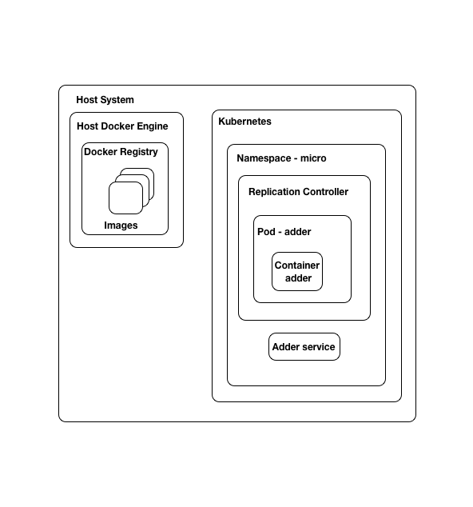

image

The structure is as follows:

* We have a Docker engine instance running on our host machine, we used this to build and tag our images
* We pushed our Docker image to a public repository on DockerHub
* Kubernetes (minikube) is running inside a VM on our local machine
* Kubernetes pulled our adderservice image from our Docker repository
* Kubernetes created a [pod](https://kubernetes.io/docs/concepts/workloads/pods/pod/) in which to run our container. Pods are managed by a replication controller which is associated with a namespace. In this case the micro namespace.
* We also created a Kubernetes [service](https://kubernetes.io/docs/concepts/services-networking/service/) to expose our adderservice container to the outside world. The service exists within our micro namespace.

A full introduction and tutorial on Kubernetes can be found on the official Kubernetes site here: https://kubernetes.io/docs/tutorials/. This tutorial provides a great explanation of the basic concepts that we need in order to work with Kubernetes. If the intricacies of our deployment thus far are still a little unclear we recommend working through the Kubernetes tutorial revisiting the diagram above before proceeding to the next recipe.

There are of course alternatives to Kubernetes, some alternatives include:

* Docker Swarm - https://docs.docker.com/engine/swarm/
* Apache Mesos - http://mesos.apache.org/
* Amazon Elastic Container Services - https://aws.amazon.com/ecs

However, Kubernetes is at the time of writing the leading container orchestration platform.

### There's more

It is important to fully understand the core concepts behind Kubernetes. To help us do this we will explore the dashboard and also push an updated container to minikube

### Using the minikube dashboard

The minikube tool comes with a built in web dashboard. While the kubectl command line client is our primary point of interaction, the dashboard is a great visual tool for exploring Kubernetes.

We can open the dashboard with the following command:

$ minikube dashbaord

If we use the menu on the left hand side to select the micro namespace we can see a summary of our deployment, it should look as follows:

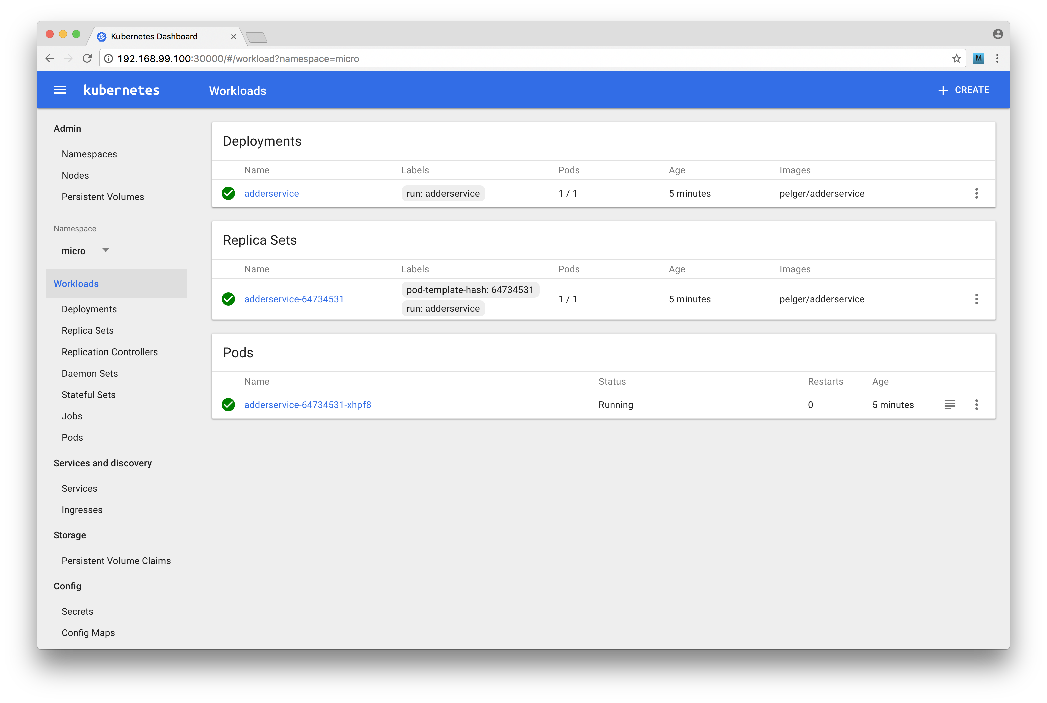

image

If we click on the logs icon in the adderservice pod line, we can view the log output from the service, which is depicted below:

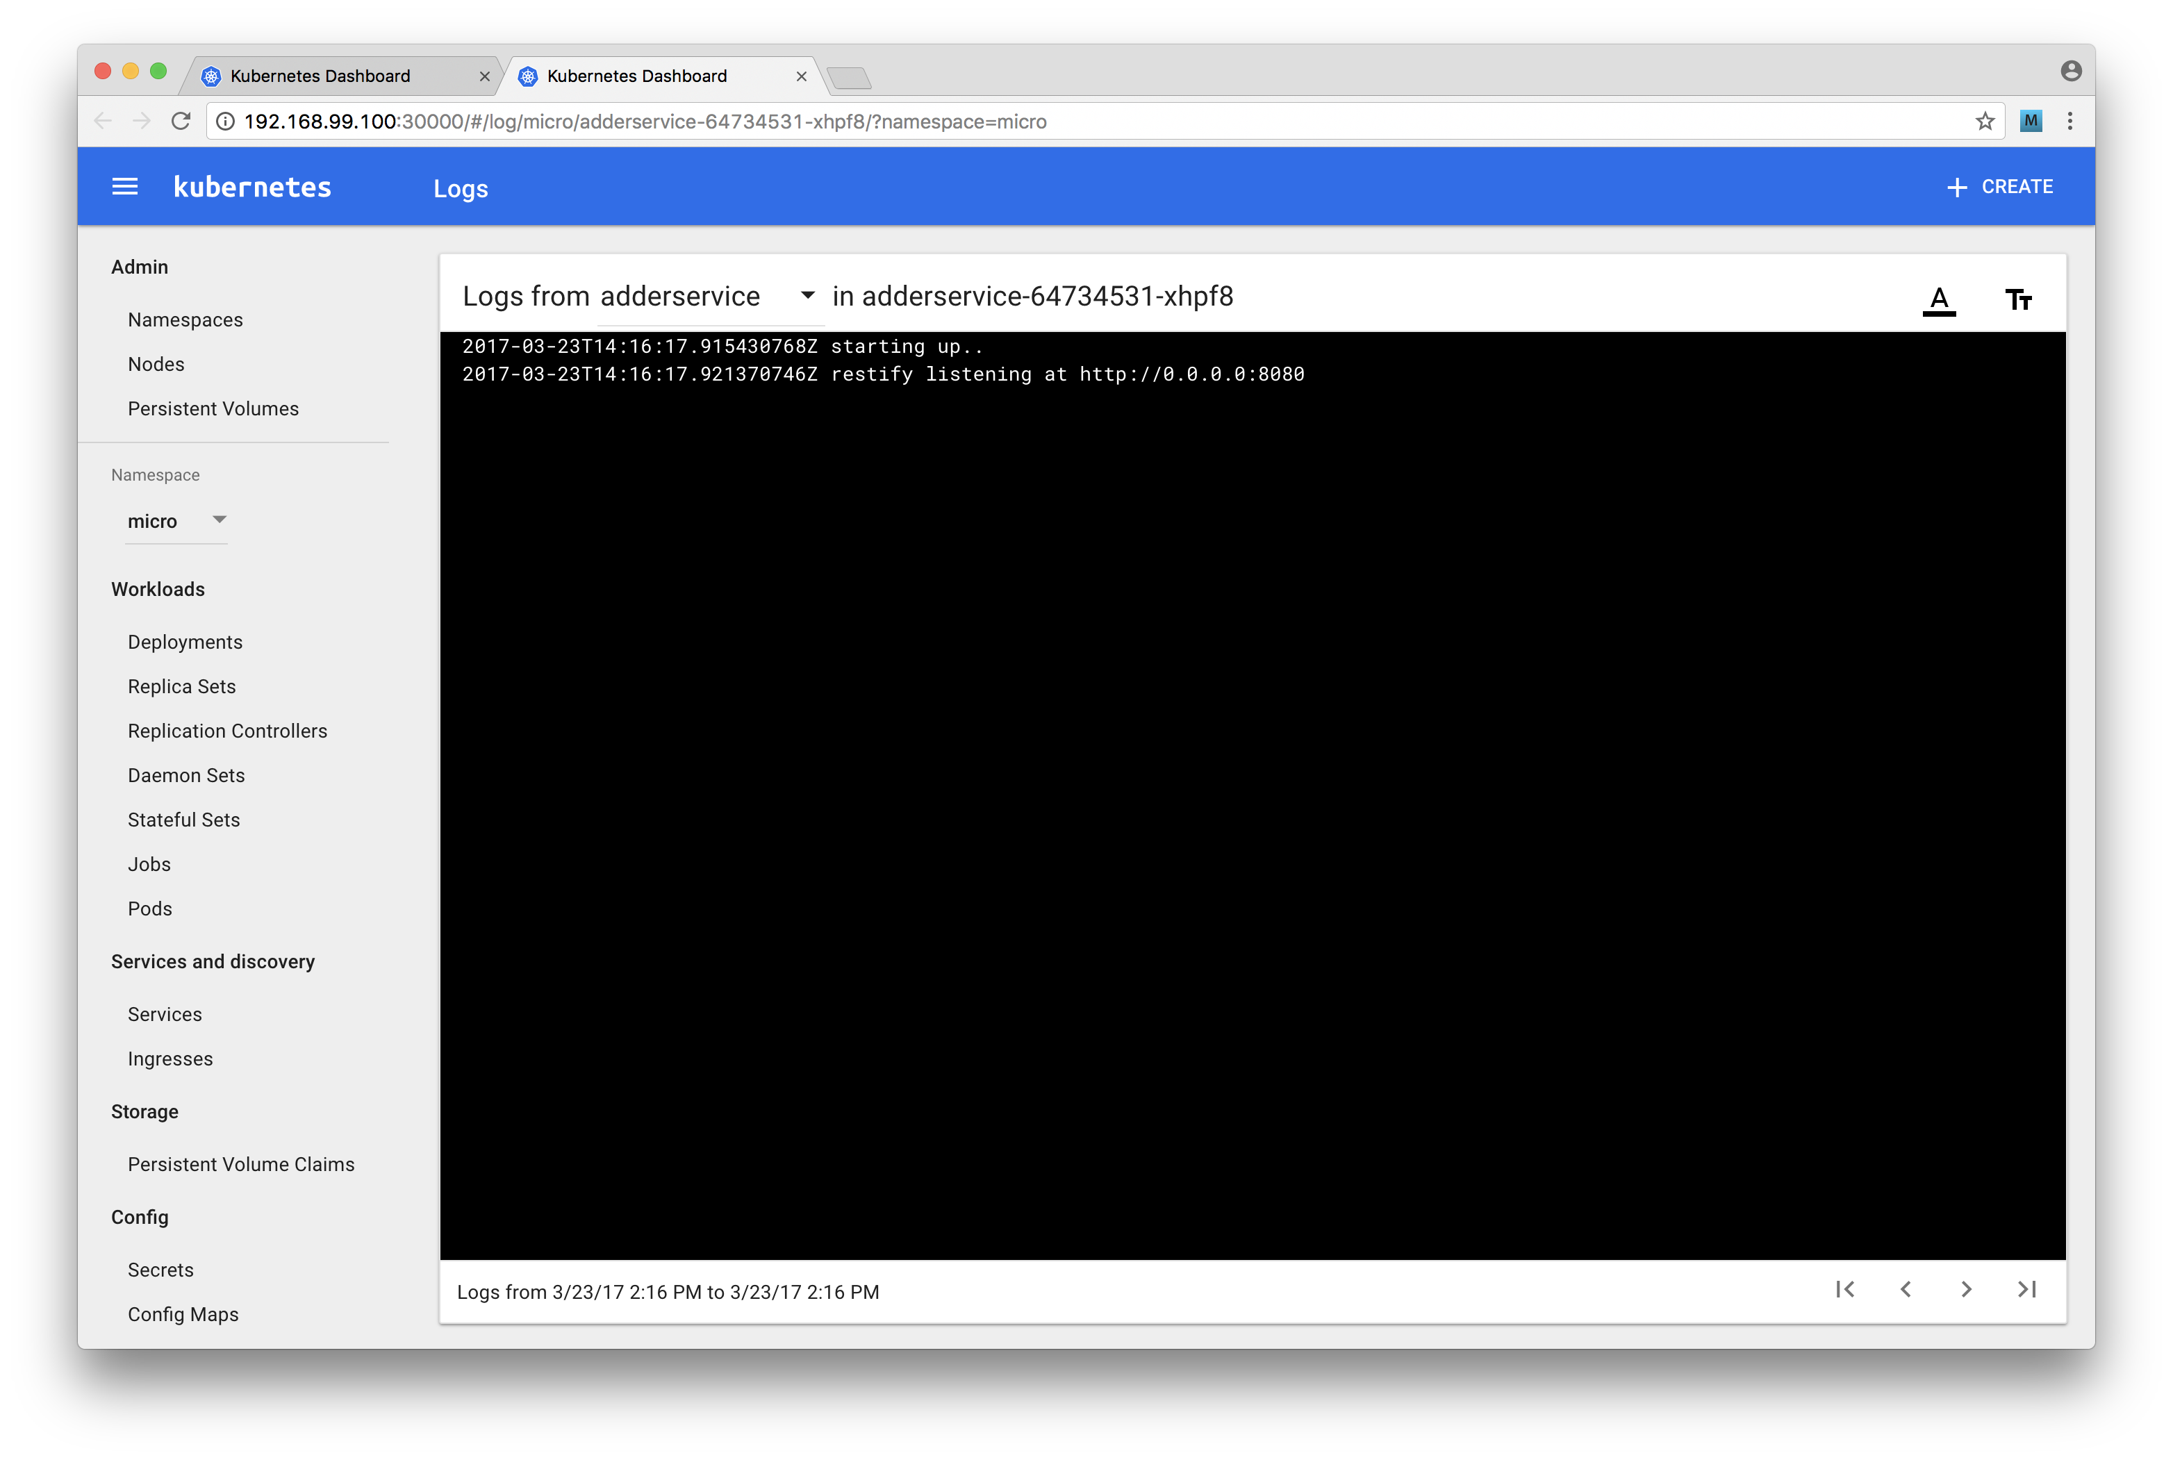

image

Let's take some time to explore the dashboard, ensuring the dashboard output mentally matches the diagram in the How it Works section for this recipe.

#### Pushing microservice updates into Kubernetes

Let's now try making a change to our service. For experimentation purposes let's copy the micro folder to micro2 as we make these changes.

Let's edit the file micro/adderservice/service.js and add some console.log statements so that it looks as below:

module.exports = service  
  
function service () {  
 function add (args, cb) {  
 const {first, second} = args  
 console.log(`add called: ${first} ${second}`)  
 const result = (parseInt(first, 10) + parseInt(second, 10))  
 cb(null, {result: result.toString()})  
 }  
  
 return { add }  
}

Let's now quickly rebuild and push our container to DockerHub:

$ cd micro2/adderservice  
$ docker build -t adderservice .  
$ docker tag adderservice <dockerhub-account>/adderservice:2  
$ docker push <dockerhub-account>/adderservice:2

Notice that we applied a version tag this time rather than using the default latest tag. Also notice that on the push Docker only needs to push a single layer, reporting that the other layers already exist. Now let's update our deployment.

Firstly let's edit the file micro/deployment/adderservice-dep.yml and update the image field to reflect the tag of the image that we just pushed, the line should read:

image: <dockerhub-account>/adderservice:2

Next tell Kubernetes to apply the change as follows:

$ cd micro2/deployment  
$ kubectl apply -f adderservice-dep.yml

Finally let's test our service and check that our log statement shows up.

As before we can use the get services command to fetch the port mappings:

$ kubectl get services

We can use curl to hit the service endpoint (assuming port 30532):

$ curl http://192.168.99.100:30532/add/1/2

Now if we open the dashboard (by running minikube dashboard) and view the logs we should see our inserted message in the log output:

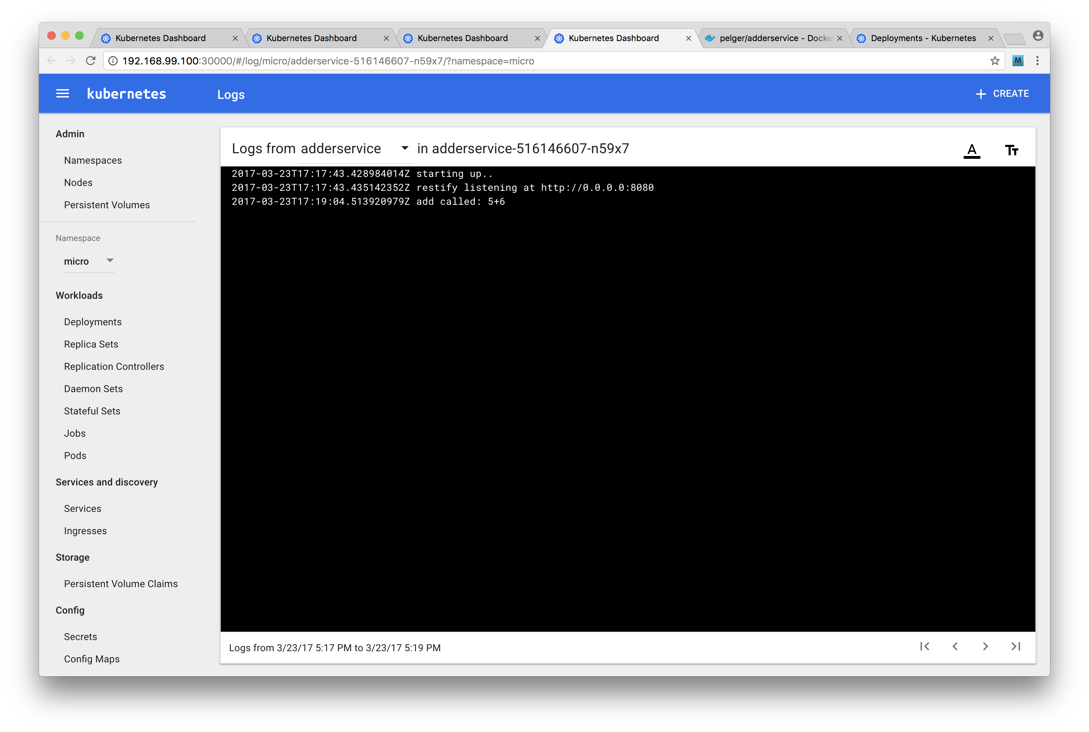

image

### See also

* *Service discovery with DNS* in **Chapter 10 Building Microservice Systems**
* *Creating a simple RESTful microservice* in **Chapter 10 Building Microservice Systems**
* *Building a container for a Node.js process* in this chapter
* *Storing Images on DockerHub* in this chapter

## Creating a deployment pipeline

In the previous recipes of this chapter we have become familiar with Docker and Kubernetes. It's now time to weild the power of these technologies by creating a deployment pipeline.

Whether we are deploying to a staging environment (Continuous Delivery) or directly to production (Continuous Deployment) a robust and automated pipeline is powerful tool that should form the core of our DevOps strategy.

In this recipe we're going to create a deployment pipeline for our system.

#### Requires bash

This recipe uses bash scripts (a common practice in creating build pipelines), thus requires a machine capable of running bash to effectively implemented (Linux, Mac and Windows 10 Pro support the bash shell).

### Getting Ready

For this recipe we are going to be using the Jenkins CI/CD system as our build and deployment tool so we will need to install this first. We can head over to https://jenkins.io/ to download the appropriate binary for our system. Once we have the the download run the installer.

Jenkins runs in the background as a daemon process. To achieve this, the installer creates a jenkins user account. This account is very restricted in what it can do which is great for security on a production build system, however we'll be loosening the restrictions for local development purposes.

We'll configure jenkins to have sudo powers. Let's run the following command:

$ sudo visudo

This will open up the sudoers file in the vi editor, add the following line to the end of the file:

jenkins ALL=(ALL) NOPASSWD:ALL

### Sudoers

We have used very loose permissions for the Jenkins user, there are other more secure methods that can be used to allow jenkins to effectively run builds We have used this method as it allows us to focus on build configuration and not security.

We also need to update the PATH environment variable for the jenkins user. To do this run the following:

$ sudo su jenkins  
$ cd ~  
$ echo export PATH="/usr/local/bin:$PATH" > .bashrc

This recipe uses the micro folder as we left it in previous recipe *Deploying a Container to Kubernetes*.

We'll be using the git version control tool in this recipe, so we need to have that installed on our system.

We'll also need a GitHub account. If we don't have a GitHub account we can navigate to http://github.com and create one.

Additionally, we need to create a GitHub repository called micro (see https://help.github.com/articles/create-a-repo/ for help on this). We'll be adding code to our GitHub repository throughout.

### How to do it

Our build pipeline is going to consist of the following steps:

* pull the latest code
* run a build step (npm install)
* run a test step (npm test)
* build an updated container, updating the version number
* push the container to DockerHub
* rollout the new container to our minikube environment

This build pipeline will be controlled and executed by Jenkins. Our pipeline will focus only on building the adderservice project. The build process relies on being able to pull the latest code from GitHub. So the first thing we need to do is initalize the micro folder as a local git repository:

$ cd micro  
$ git init

To keep the repository clean let's add a .gitignore file at the root containing the following:

.DS_Store  
*.log  
node_modules  
npm-debug.log

We also need to make a slight change to package.json in the adderservice. Update the test command in the scripts section to read as follows:

''' scripts { "test": "echo "no test specified" && exit 0" } '''

By default npm will insert an exit 1 command which would cause our test build phase to fail.

### Testing is important

Note that we are not advocating skipping the test phase. Robust unit testing is a key practice for any system's development. However the focus of this recipe is on constructing a build pipeline not on the content of any unit tests we might write.

We can now add the contents of the micro folder into our local git repository, make the first commit, add the remote origin and push to GitHub.

$ git add .  
$ git commit -m '1st'  
$ git remote add origin https://github.com/<user>/micro.git  
$ git push -u origin master

In these steps, we substitute <user> with the name of our GitHub user account.

Before we wire up Jenkins, we are going to create our build script. We're also going to make our Kubernetes deployment a little more generic.

Let's create two new files in the micro/deployment folder:

$ cd micro/deployment  
$ touch deployment-template.yml service-template.yml

The deployment-template.yml should look like so:

apiVersion: extensions/v1beta1  
kind: Deployment  
metadata:  
 name: _NAME_  
spec:  
 replicas: 1  
 template:  
 metadata:  
 labels:  
 run: _NAME_  
 spec:  
 containers:  
 - name: _NAME_  
 image: _IMAGE_  
 ports:  
 - containerPort: _PORT_

The service-template.yml should contain the following code:

apiVersion: v1  
kind: Service  
metadata:  
 name: _NAME_  
 labels:  
 run: _NAME_  
spec:  
 ports:  
 - port: _PORT_  
 name: main  
 protocol: TCP  
 targetPort: _PORT_  
 selector:  
 run: _NAME_  
 type: NodePort

Our new template files are simply the previous Kubernetes deployment scripts which we created in the *Deploying a container to Kubernetes* recipe with the specific service name, port and image replaced with the string _NAME_, _PORT and _IMAGE_. Since previous scripts are now redundant let's go ahead and remove them:

$ rm adderservice*.yml

### Build scripts

Jenkins and other build systems can be powerful all-encompassing tools. However we recommend writing simple build scripts which are then triggered or managed by automation software like Jenkins. This layer of separation keeps us decoupled from the build tool, and could make debugging easier since we've written the build scripts using familiar languages and tools.

Next we'll write a build script for the adderservice.

Let's create a build.sh file in the micro/adderservice folder:

sh $ cd ../adderservice # assuming cwd is micro/deployment $ touch build.sh

Our build.sh file should look as follows,

#!/bin/bash  
source ~/.bashrc  
GITSHA=$(git rev-parse --short HEAD)  
  
case "$1" in  
 container)  
 sudo -u <username> docker build -t adderservice:$GITSHA .  
 sudo -u <username> docker tag adderservice:$GITSHA \  
 <dockerhub account>/adderservice:$GITSHA  
 sudo -i -u <username> docker push \  
 <dockerhub account>/adderservice:$GITSHA  
 ;;  
 deploy)  
 sed -e s/_NAME_/adderservice/ -e s/_PORT_/8080/ \  
 < ../deployment/service-template.yml > svc.yml  
 sed -e s/_NAME_/adderservice/ -e s/_PORT_/8080/ \  
 -e s/_IMAGE_/<dockerhub account>\\/adderservice:$GITSHA/ \  
 < ../deployment/deployment-template.yml > dep.yml  
 sudo -i -u <dockerhub account> kubectl apply -f $(pwd)/svc.yml  
 sudo -i -u <dockerhub account> kubectl apply -f $(pwd)/dep.yml  
 ;;  
 *)  
 echo invalid build step  
 exit 1  
 ;;  
esac

Here we need to replace with our username, i.e. the account that we log into our computer with. Replace with our DockerHub user account name.

### Templates and sed

We are using sed as a simple way of running a template based build script. There is discussion in the Kubernetes community on adding templates to Kubernetes but this is not currently supported. sed is an easy way to create a template based solution.

Next we'll wire our build script into Jenkins. We'll be using a Jenkin's feature called [pipelines](https://jenkins.io/doc/book/pipeline/).

Pipelines are described in text files named Jenkinsfile (by convention).

Let's create a Jenkinsfile for our addderservice build pipeline:

$ touch Jenkinsfile # cwd should be micro/adderservice

The contents of our Jenkinsfile should look as follows:

pipeline {  
 agent any  
  
 stages {  
 stage('Checkout') {  
 steps {  
 checkout scm  
 }  
 }  
 stage('Build') {  
 steps {  
 sh 'source ~/.bashrc && cd adderservice && npm install'  
 }  
 }  
 stage('Test'){  
 steps {  
 sh 'source ~/.bashrc && cd adderservice && npm test'  
 }  
 }  
 stage('Container'){  
 steps {  
 sh 'source ~/.bashrc && cd adderservice && sh build.sh \  
 container'  
 }  
 }  
 stage('Deploy'){  
 steps {  
 sh 'source ~/.bashrc && cd adderservice && sh build.sh deploy'  
 }  
 }  
 }  
}

Now we'll commit and push our changes thus far to our GitHub repository:

$ cd micro  
$ git add .  
$ git commit -m 'build script'  
$ git push origin master

Great! Now we need to hook up Jenkins. To do we'll open the Jenkins web interface at http://localhost:8080.

Select the New Item link on the left hand menu and create a new pipeline project called adderservice as illustrated below:

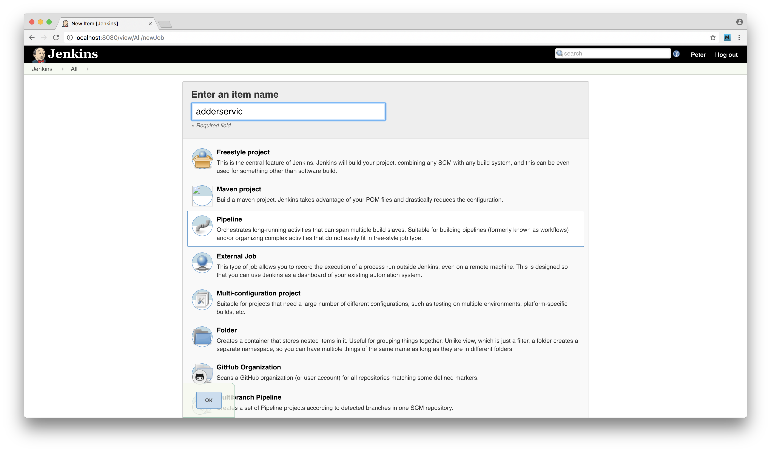

image

Then we'll configure the pipeline by pointing it to our GitHub repository. Under the *General* heading we should select *GitHub project* input and provide the url to the project.

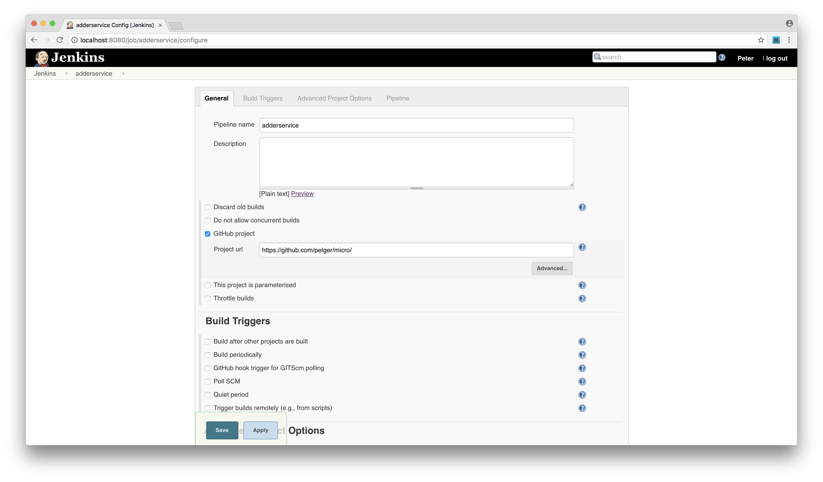

image

We also need to configure the pipeline settings under the *Pipeline* tab, with SCM set to Git, a single repository with the *Repository URL* set to our GitHub repository (in .git format), *Branch specifier* set to */master and *Script Path* configured as adderservice/Jenkinsfile, as illustrated in the following image:

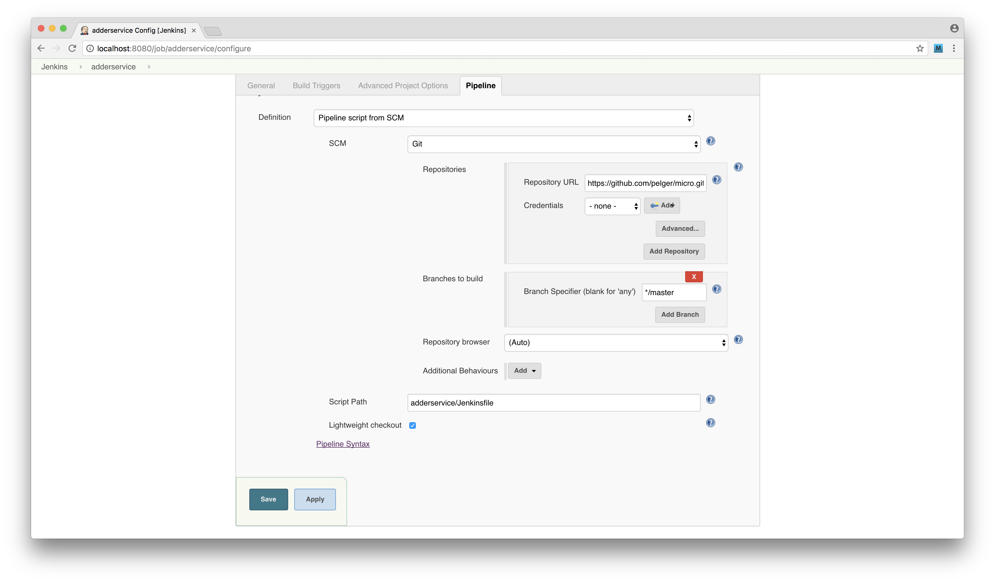

image

Once we have these settings configured and saved, we're able to test our pipeline.

From the main Jenkins menu we can click the *adderservice* link, then click the *build now* link. Jenkins will initiate the pipeline, building and deploying our service to Kubernetes.

Once the build is complete we can view Jenkins overview screen as in the following screenshot:

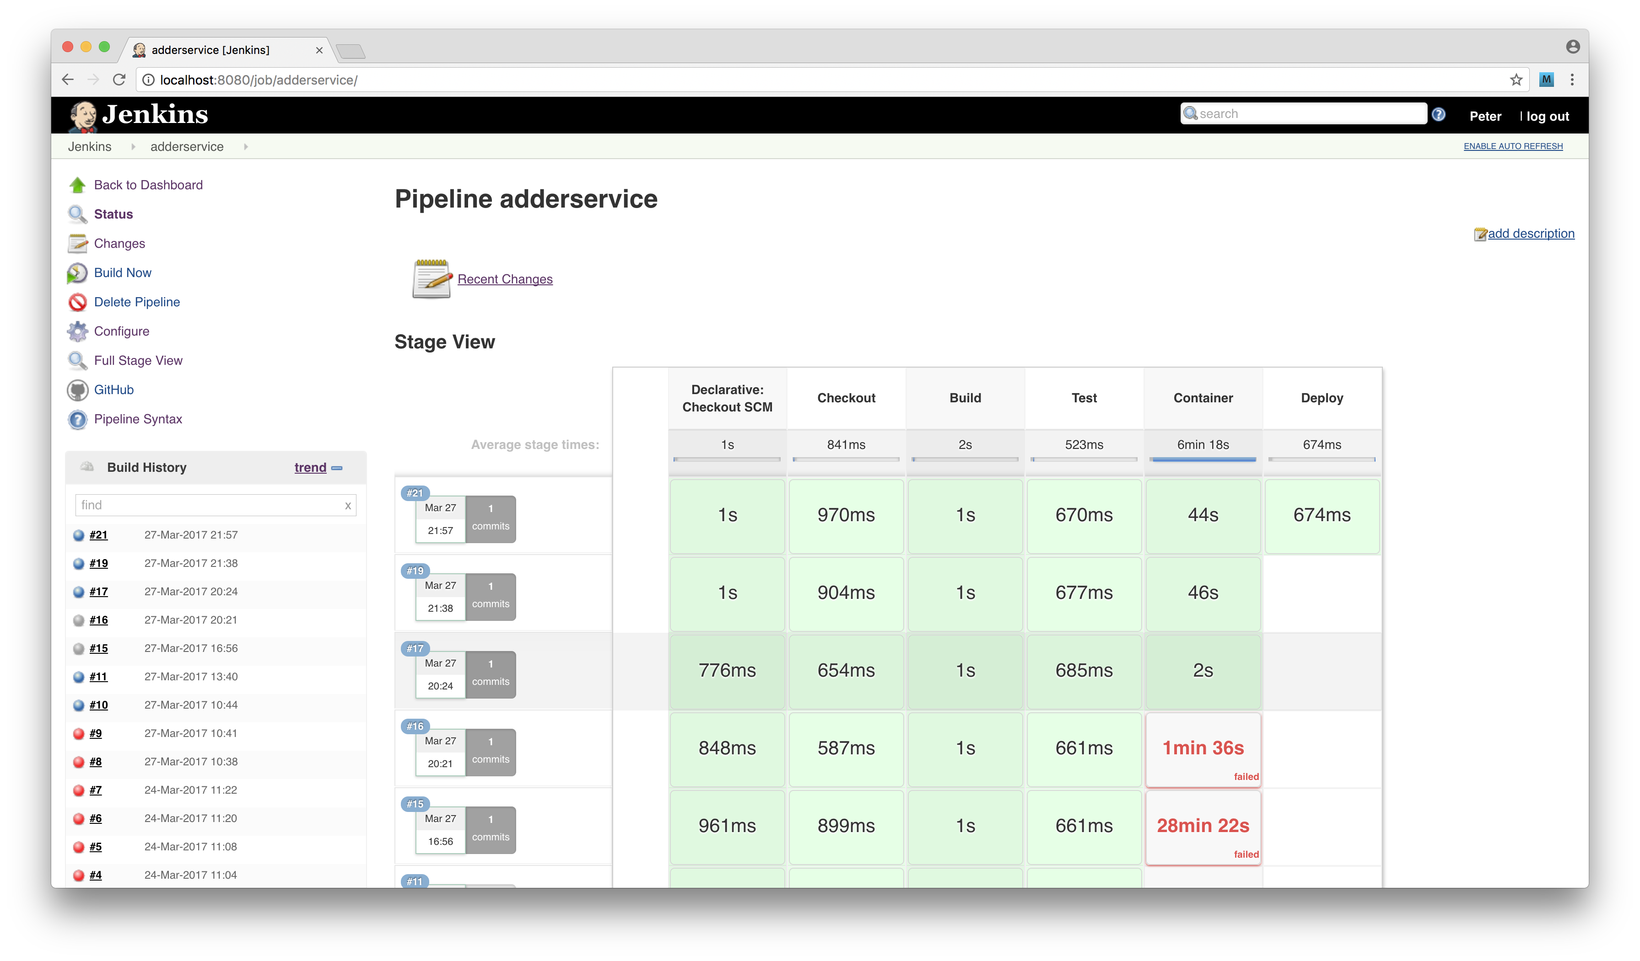

image

We can also inspect a builds log output via in Jenkins as in the following screenshot:

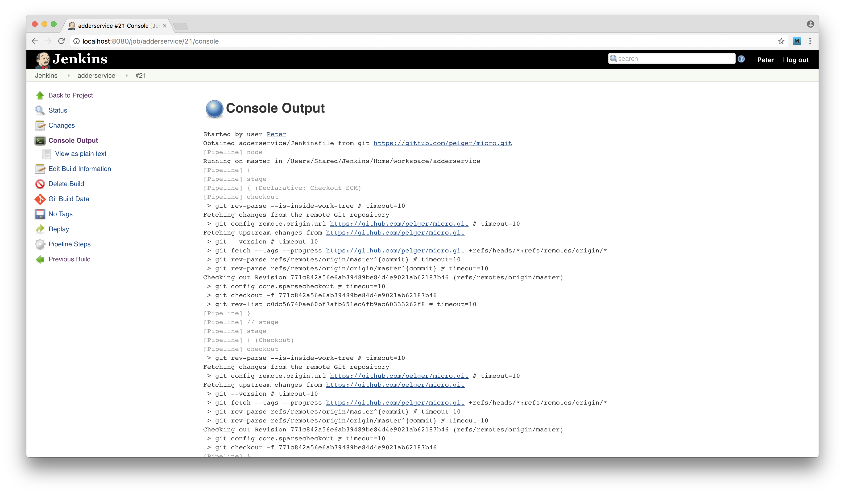

image

Finally we can use the minikube dashboard to inspect the state of our Kubernetes cluster after the build:

$ minikube dashboard

We should see that a fresh pod has been deployed along with our newly created container image.

### How it works

We've accomplished a lot so far, let's break it down into pieces.

Let's begin with the build script, The first line reads the short form Git SHA for the current branch in our micro project using this code:

GITSHA=$(git rev-parse --short HEAD)

Later in the script we used the SHA to tag our image and to upload it to DockerHub.

sudo -u <username> docker tag adderservice:$GITSHA <dockerhub account>/adderservice:$GITSHA  
sudo -i -u <username> docker push <dockerhub account>/adderservice:$GITSHA

Using a Git SHA as a tag on a container image is a useful technique because it means that we can identify the exact code that is in the container by cross referencing the container tag with the git history (which can be viewed using git log).

There are of course other valid tagging strategies, such as using the npm version number from package.json or some kind other independent build number.

We used the following code to generate our Kubernetes deployment configuration from our templates:

sed -e s/_NAME_/adderservice/ -e s/_PORT_/8080/ \  
 < ../deployment/service-template.yml > svc.yml  
sed -e s/_NAME_/adderservice/ -e s/_PORT_/8080/ \  
 -e s/_IMAGE_/<user>\\/adderservice:$GITSHA/ \  
 < ../deployment/deployment-template.yml > dep.yml

This is just using sed the stream editor to replace our template strings with the required values for the deployment. The output files are written to svc.yml for the service and dep.yml for the deployment. Finally in the deployment stage we use kubectl to apply the updated container using the files we generated through sed

sudo -i -u <user> kubectl apply -f $(pwd)/svc.yml  
sudo -i -u <user> kubectl apply -f $(pwd)/dep.yml

Note that we use the pwd command to generate an absolute path because of the context that this script is run in by Jenkins differs from our terminal session (meaning, that the working directories are not the same).

Let's take a look at the adderservice/Jenkinsfile again. It's broken down into a number of stages. Jenkins scans the repository that we nominated when we configured the pipeline through the Jenkins web interface. Jenkins reads the Jenkinsfile and begins executing the first phase (the stage('Checkout') phase).

Here Jenkins will get a pull a full copy of our micro GitHub repository into a temporary build area.

The next two stages (state('Build') and stage('Test')) run npm install and npm test as the build and test phases. We define unit tests for the adderservice since it was beyond our scope, but in an actual system the test phase should break the build pipeline on test failure by returning a non-zero exit code. In the test phase we might also apply other constraints such as minimum coverage levels or code linting.

In the stage('Container') phase we build, tag and upload our new container image to DockerHub. Finally we apply the changes to Kubernetes in the deployment phase. It is important to note that our approach when using tools like Jenkins is to always do the minimum work within the tool itself and to handle the build as much as possible in external scripts. This makes our build process much easier to debug and also much more portable.

We should note that Jenkins is just one of a number of CI/CD tools, although it is very widely used. There are several noteworthy alternatives, including:

* Bamboo - Part of the Atlassian tool suite https://www.atlassian.com/software/bamboo
* Travis - Cloud based build tool free for use with public projects https://travis-ci.org/
* Circle CI - Fully featured, commercial build tool https://circleci.com/
* Go - from ThroughtWorks https://www.gocd.io/

### There's more

We accomplished a lot in this recipe! We now have a Jenkins controlled pipeline building and deploying our adderservice container to Kubernetes. Let's explore how we might debug this build process and also automatically trigger it.

#### Debugging the build

If we encounter any issues with the build process, Jenkins will report these in the output logs. Once we have made a correction to our build scripts we will need to commit and push them to GitHub before telling Jenkins to rebuild. This results in quite a long development cycle. A much better way is to test the scripts directly in a shell so that we can be sure they're working before committing for Jenkins to build.

To do this we need to test our scripts in the context of the jenkins user. We can do this using the sudo command.

Let's run the container build step in isolation:

$ cd micro/adderservice  
$ sudo su jenkins  
$ sh build.sh container

This allows us to figure out any environmental or permission issues with a build step before committing the code. Remember to exit from the jenkins user login once we are done debugging. The whoami command, which tells us the context of the user our shell is running in, can be generally useful in this process.

#### Automating the build trigger

In the main recipe we manually triggered the build in Jenkins, this isn't ideal. A preferable approach is to trigger the build as code is checked into the master branch.

Let's configure Jenkins and GitHub to automate the build process.

We need to create a GitHub API access token. Let's go to http://github.com, and login if we're not already. Next we click the *settings* link from right hand drop down menu (located next to our profile picture). Under the Developer settings menu on the left hand side click the Personal access tokens link (following this navigation should lead to https://github.com/settings/tokens).

Next we set the permissions on the token as per the image below:

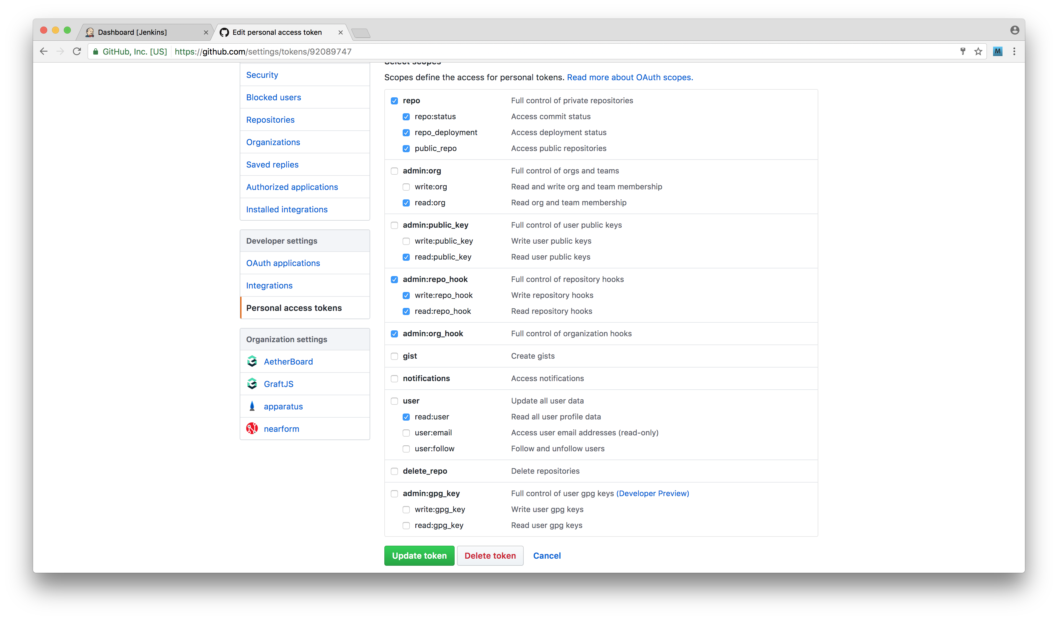

image

Once the token has been created it's only displayed once on the GitHub UI so we should copy and paste the token string somewhere for safe keeping.

Next we need to make our access token available to Jenkins. We can achieve this by opening the main Jenkins dashboard page and clicking the *credentials* link on the left hand menu. Following this we click the *system link* and then select the *add credentials* link under the global scope (this should lead us to http://localhost:8080/credentials/store/system/domain/_/newCredentials).

Then we can complete the form shown in the following screenshot:

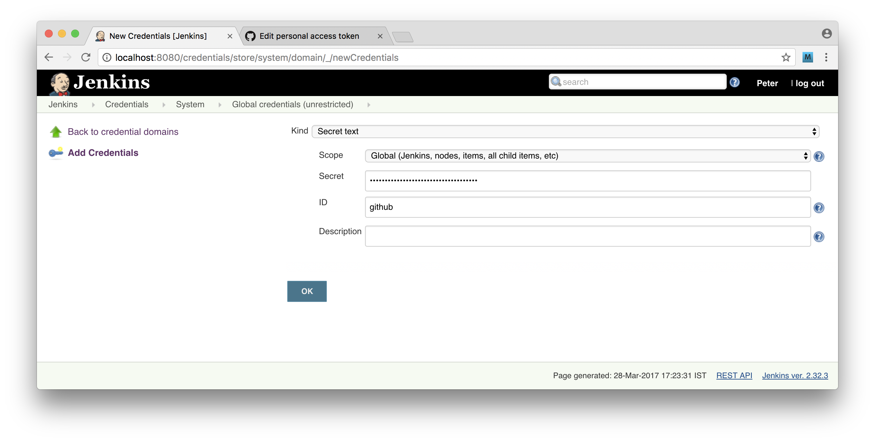

image

Select the type as secret text and paste in the access token from GitHub into the secret field. Next we need to configure the Jenkins GitHub plugin. Naviage to the main Jenkins dashboard and then hit the link to Manage Jenkins then the Configure System link, scroll down to the Githuib section and configure it as depicted below:

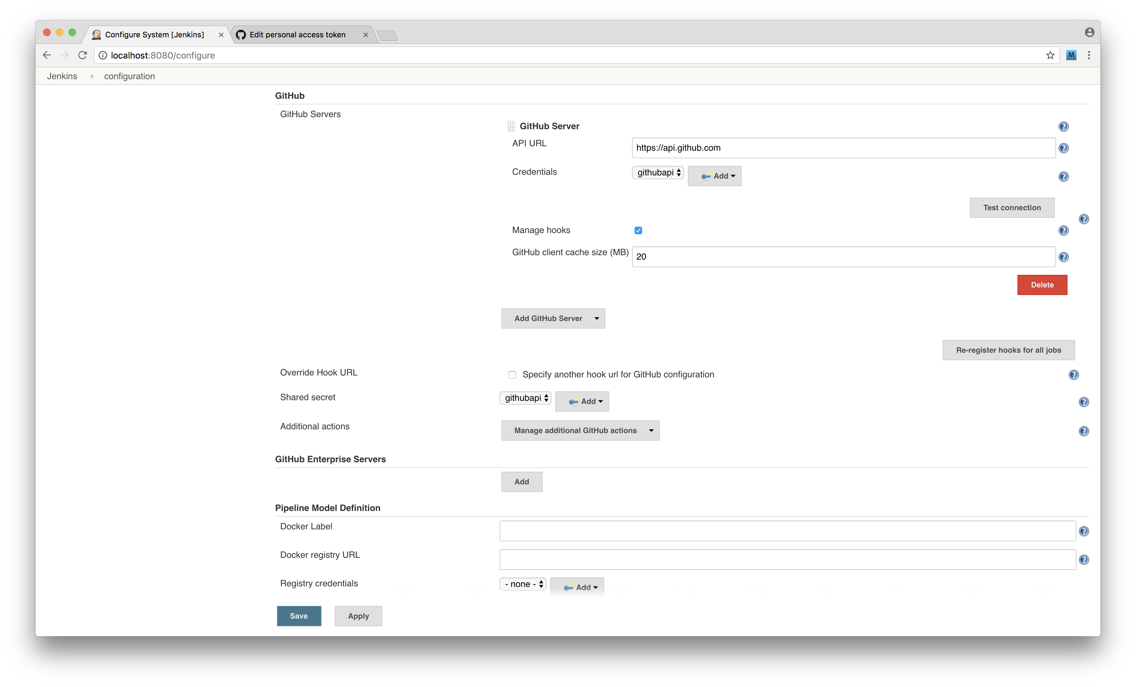

image

Using the credentials that we created in the previous step. We can use the *Test Connection* button to check that our access is setup correctly.

Finally we need to configure our pipeline so that it's triggered from GitHub.

We navigate to the configuration screen for our pipeline and scroll down to the *Build Triggers* section. Then we select the *Poll SCM* option and the string * * * * * in the schedule box.

### Webhooks

We are using polling in this recipe because our Jenkins server is running on localhost. A more efficient way to trigger a build is to setup a GitHub webhook. Using this technique, GitHub will call a nominated url on certain events such as a branch merge.

Now that we have GitHub polling configured we can go ahead and trigger a build by pushing to GitHub.

We can make a small change to our project, for example adding an additional console.log or a comment to the code and push the change to our master branch.

For instance, we could make our adderservice/index.js look like so:

console.log('BUILD ME :D')  
const wiring = require('./wiring')  
const service = require('./service')()  
  
wiring(service)

Then we would use the following commands to add the change, commit, and push to GitHub:

$ cd micro  
$ git add adderservice/index.js  
$ git commit -m 'test build'  
$ git push

Jenkins will pick this change the next time it polls github and automatically run the full pipeline for us right through to deploying new pods on Kubernetes!

### See also

* *Creating a simple RESTful microservice* in **Chapter 10 Building Microservice Systems**
* *Storing Images on DockerHub* in this chapter
* *Deploying a Container to Kubernetes* in this chapter
* *Deploying a full system* in this chapter

## Deploying a full system

Now that we have experience with containers and building a deployment pipeline for a single service, we're going to build a deployment pipeline for an entire microservice system.

We'll be setting this up to work on our local machine for now, but in the next recipe we'll explore how to lift this into a cloud environment.

### Getting Ready

In **Chapter 10 Building Microservice Systems** we developed a small microservice system. For this recipe we will be deploying this system using techniques used in the previous recipes in this chapter.

So to prepare we need to grab a copy micro folder from the last recipe of chapter 10 *Adding a queue based service*, we'll by copy folders from this recipe into the micro folder in previous recipe of this chapter *Creating a deployment pipeline*.

Since we're building on the work of the previous recipe it is necessary to complete it before proceeding with this one.

We also assume that Docker, Minikube and Jenkins are installed locally as required by the previous recipe.

If GitHub triggers are running for the adderservice in Jenkins (using SCM Polling) then now would be a good time to temporarily disable these while we work on the rest of the pipeline.

### How to do it

We need to add the code for the rest of the system into our micro repository that we created in the previous recipe.

To do this copy the following top level directories from the *Adding a queue based service* micro folder into the root of our current micro folder (the one which is initialized as a GitHub) repository:

* auditservice
* eventservice
* webapp
* report
* fuge

Our micro repository directory structure should now look as follows:

micro  
├── .gitignore  
├── adderservice  
├── auditservice  
├── deployment  
├── eventservice  
├── fuge  
├── report  
└── webapp

Let's go ahead and commit our changes and push them to GitHub:

$ cd micro  
$ git add .  
$ git commit -m 'added services and webapp'  
$ git push origin master

Now let's apply the same build structure to eventservice, auditservice and webapp.

### Check with Fuge

We have copied across our Fuge config (fuge/fuge.yml) with our microservice system. We can start the system up anytime with Fuge to check that the system is running correctly (simply run fuge shell fuge/fuge.yml). Note that Jenkins runs on port 8080 by default, as does our adderservice which leads to an unfortunate port conflict, so when testing in Fuge we would need to stop Jenkins temporarily. It's left as an exercise for the reader to solve this collision.

To do this copy the files .dockerignore, Dockerfile, Jenkinsfile and build.sh from the adderservice folder to each of the eventservice, auditservice and webapp folders.

$ cp adderservice/{.dockerignore,Dockerfile,Jenkinsfile,build.sh} eventservice  
$ cp adderservice/{.dockerignore,Dockerfile,Jenkinsfile,build.sh} auditservice  
$ cp adderservice/{.dockerignore,Dockerfile,Jenkinsfile,build.sh} webapp

Once copied we will need to modify the Jenkinsfile and build.sh files to match the service that they are now pertaining to.

Specifically this means replacing references to the name of the service (which currently be adderservice) and the port number.

We can do the bulk of necessary customizations quickly with sed. We can process each Jenkinsfile like so:

$ cat auditservice/Jenkinsfile | sed -e s/adderservice/auditservice/ | tee auditservice/Jenkinsfile  
$ cat eventservice/Jenkinsfile | sed -e s/adderservice/eventservice/ | tee eventservice/Jenkinsfile  
$ cat webapp/Jenkinsfile | sed -e s/adderservice/webapp/| tee webapp/Jenkinsfile

The build.sh we can alter in similar form:

$ cat auditservice/build.sh | sed -e s/adderservice/auditservice/ -e s/8080/8081/ | tee auditservice/build.sh  
$ cat eventservice/build.sh | sed -e s/adderservice/eventservice/ -e s/8080/8082/ | tee eventservice/build.sh  
$ cat webapp/build.sh | sed -e s/adderservice/webapp/ -e s/8080/3000/ | tee webapp/build.sh

Notice how we also convert the port number in each case from 8080 to the relevant port for the service (based on how we've typically mapped services to ports thus far, as laid out initially in fuge/fuge.yml).

As in our previous recipe, we need to tweak test field in the package.json for each service so it has an exit code of zero. As mentioned previously, we're simulating successfully passing unit tests, but in a real scenario we would want each service to run unit tests instead of having a faux successful exit code.

We can run the following commands to alter the package.json in each service:

$ node -e 'o = require(`./auditservice/package.json`);o.scripts.test = `echo "Error: no test specified" && exit 0`;fs.writeFileSync(`./auditservice/package.json`, JSON.stringify(o, 0, 2))'  
$ node -e 'o = require(`./eventservice/package.json`);o.scripts.test = `echo "Error: no test specified" && exit 0`;fs.writeFileSync(`./eventservice/package.json`, JSON.stringify(o, 0, 2))'  
$ node -e 'o = require(`./webapp/package.json`);o.scripts.test = `echo "Error: no test specified" && exit 0`;fs.writeFileSync(`./webapp/package.json`, JSON.stringify(o, 0, 2))'

The webapp/Dockerfile should be modified with the final CMD set to npm start instead of node index.js.

The entire the webapp/Dockerfile should look as follows:

FROM node:slim  
RUN mkdir -p /home/node/service  
WORKDIR /home/node/service  
COPY package.json /home/node/service  
RUN npm install  
COPY . /home/node/service  
CMD [ "npm", "start" ]

Once we have completed these changes for the auditservice, eventservice and webapp, we can commit them to the GitHub master branch.

$ git add .  
$ git commit -m 'added build files'  
$ git push

### Independent variation

We have chosen to clone and modify our build script and Jenkinsfile for each service. While we could have created a single parameterized script to deploy our services it is usually better to have a build script per service. That way the build may be customized as required for each service without introducing complication into a master build script.

Recall from our microservice chapter that the auditservice and eventservice require mongodb and redis to run correctly so we need to ensure that these elements are deployed as part of our overall pipeline. To do this create a directory called infrastructure under micro and add a build.sh and a Jenkinsfile which should contain the following code, for build.sh:

#!/bin/bash  
source ~/.bashrc  
case "$1" in  
 mongo)  
 sed -e s/_NAME_/mongo/ -e s/_PORT_/27017/ \  
 < ../deployment/service-template.yml > svc.yml  
 sed -e s/_NAME_/mongo/ -e s/_PORT_/27017/ -e s/_IMAGE_/mongo/ \  
 < ../deployment/deployment-template.yml > dep.yml  
 sudo -i -u <user> kubectl apply -f $(pwd)/svc.yml  
 sudo -i -u <user> kubectl apply -f $(pwd)/dep.yml  
 ;;  
 redis)  
 sed -e s/_NAME_/redis/ -e s/_PORT_/6379/ \  
 < ../deployment/service-template.yml > svc.yml  
 sed -e s/_NAME_/redis/ -e s/_PORT_/6379/ -e s/_IMAGE_/redis/ \  
 < ../deployment/deployment-template.yml > dep.yml  
 sudo -i -u <user> kubectl apply -f $(pwd)/svc.yml  
 sudo -i -u <user> kubectl apply -f $(pwd)/dep.yml  
 ;;  
 *)  
 echo 'invalid build command'  
 exit 1  
 ;;  
esac

The Jenkinsfile should look as follows:

pipeline {  
 agent any  
  
 stages {  
 stage('Checkout') {  
 steps {  
 checkout scm  
 }  
 }  
 stage('DeployMongo'){  
 steps {  
 sh 'source ~/.bashrc && cd infrastructure && sh build.sh mongo'  
 }  
 }  
 stage('DeployRedis'){  
 steps {  
 sh 'source ~/.bashrc && cd infrastructure && sh build.sh redis'  
 }  
 }  
 }  
}

We can now commit and push the infrastructure additions to GitHub:

$ git add infrastructure  
$ git commit -m 'infrastructure'  
$ git push

Now we're ready to configure Jenkins.

From the main Jenkins dashboard let's click *New Item* and select the *Pipeline* type. We'll name the pipeline *infrastructure*. Jenkins provides a convenient shortcut, we can instruct Jenkins to copy settings from *adderservice* pipeline configuration as shown below.

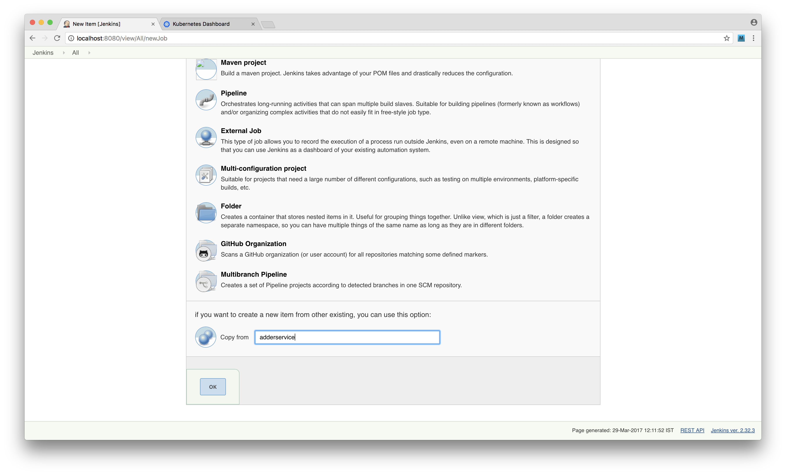

image

This means we also copy the GitHub configuration the *infrastructure* pipeline automatically. It also means that the *Script Path* setting points to the adderservice/Jenkinsfile instead of infrastructure/Jenkinsfile. Let's navigate to the configuration screen for the *infrastructure* pipeline section and change the *Script Path* setting from *adderservice/Jenkinsfile* to *infrastructure/Jenkinsfile*. We can now manually trigger a build of our infrastructure pipeline. Once this is done we can inspect Kubernetes using the dashboard:

$ minikube dashboard

Which should look similar to below:

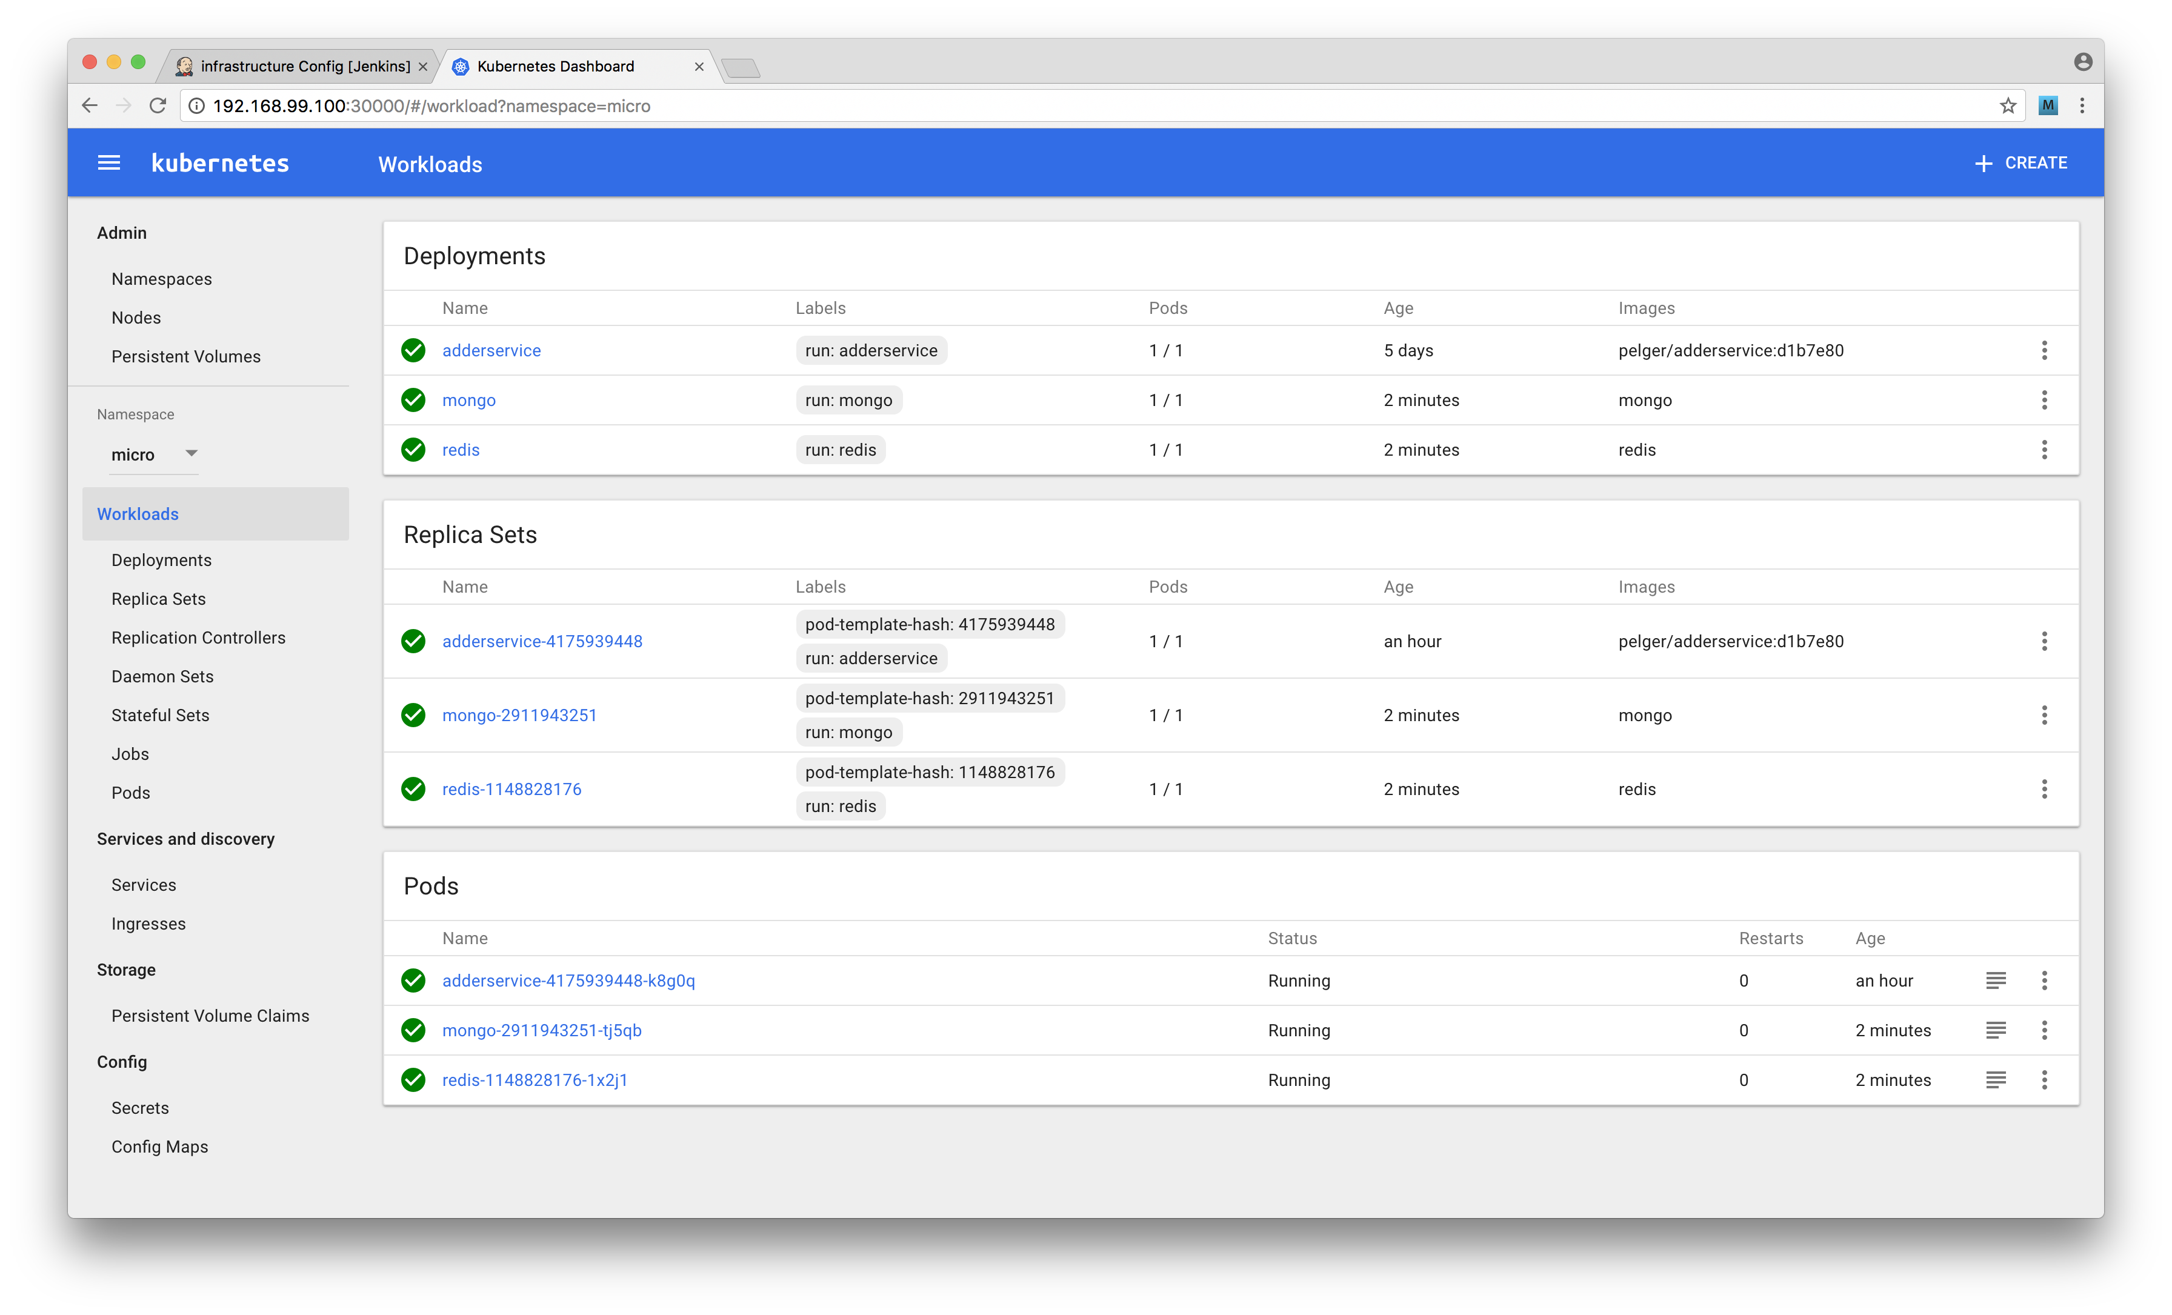

image

That takes care of our infrastructure. We now just need to configure our other services. To do this repeat the above steps for each of eventservice, auditservice and webapp making sure to copy settings from adderservice and updating the Script path setting in each case.

Once we completed this our main Jenkins dashboard should look as below:



image

We can now trigger builds for each of our services and the webapp by clicking the left hand menu, selecting each and clicking *build now*.

Once all of the builds have completed we can open up the minikube dashboard which should look similar to the image below:

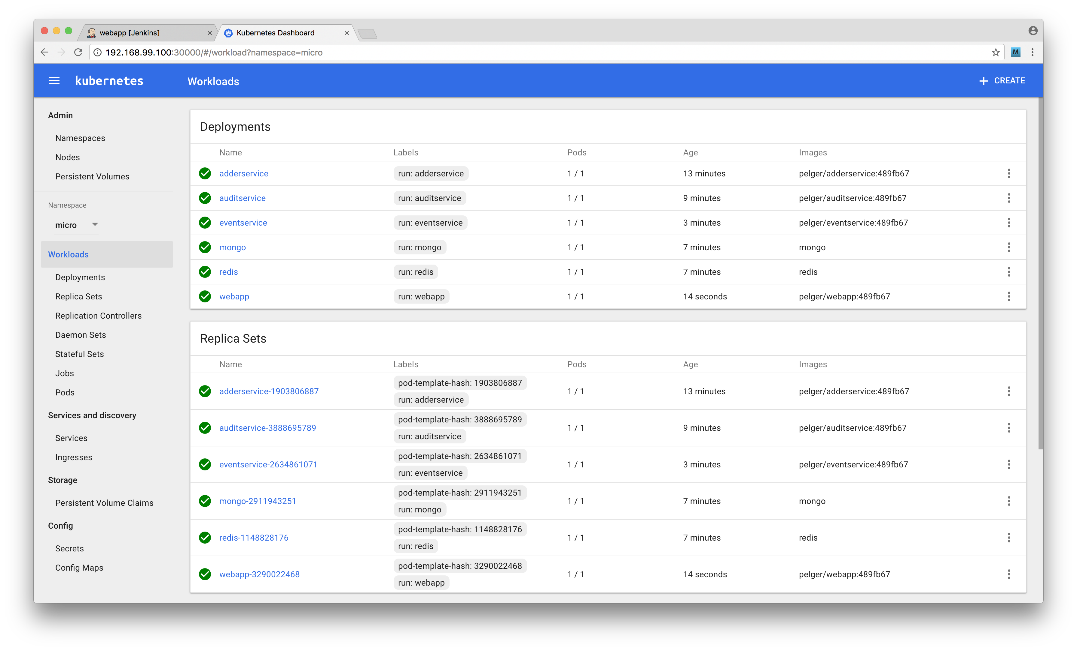

image

Finally we can test that our system is up and running correctly.

We need to determine the external port number that Kubernetes assigned to our web app and also the Kubernetes IP address:

$ minikube ip  
192.168.99.100  
$ kubectl get services  
NAME CLUSTER-IP EXTERNAL-IP PORT(S) AGE  
adderservice 10.0.0.139 <nodes> 8080:30743/TCP 22m  
auditservice 10.0.0.209 <nodes> 8081:32391/TCP 19m  
eventservice 10.0.0.41 <nodes> 8082:32104/TCP 13m  
mongo 10.0.0.172 <nodes> 27017:31000/TCP 17m  
redis 10.0.0.57 <nodes> 6379:31863/TCP 17m  
webapp 10.0.0.54 <nodes> 3000:30607/TCP 9m

In the case of the output above we can see that the webapp is available on IP address 192.168.99.100 port number 30607. If we now go ahead and point our browser to http://192.168.99.100:30607/add we should see the webapp page rendered as before. When we enter some numbers and press add we should see a result. Also the audit link at http://192.168.99.100/30607/audit should show a recording of all of our calculations.

The final thing to do is to automate the build pipeline to trigger after pushing to GitHub.

To do this we need to repeat the step of the previous recipe by selecting the Poll SCM setting for each project and setting the schedule to * * * * * to poll every minute.

### How it works

We now have a functioning microservice system with a continuous delivery pipeline.

This is depicted in the image below:

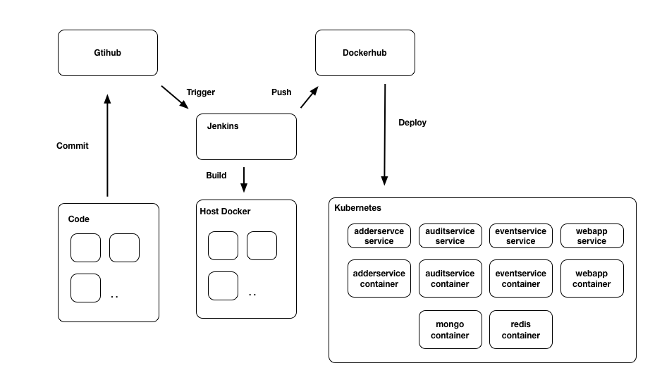

image

Once a commit is pushed to the master branch, Jenkins will pull the latest version of the code, run build and test steps before creating a new container image. Once the image is created it is pushed up to DockerHub. Jenkins then triggers a deployment into Kubernetes. Kubernetes pulls the nominated image from DockerHub and creates a new pod. The old pod is then discarded.

We have created independent pipelines for our adderservice, auditservice, eventservice and webapp

This is a good point to note the ease of transition from running our system in development mode using Fuge (the microservice development toolkit used in several recipes in **Chapter 10 Building Microservice Systems**) to running our system in Kubernetes. This down to our code being written from the start to use the same service discovery mechanisms in both environments.

### There's more

While Kubernetes can seem a little overwhelming at first, exploring some more *power user* techniques can help with mastering it.

One helpful technique is opening a shell inside a Kubernetes managed container.

Let's try this out.

#### Running a report

Recall that in the recipe *Adding a queue based service* in **Chapter 10 Building Microservice Systems** we created a reporting utility that displayed URL counts for our system. Let's run this again but from inside of Kubernetes. To do this we need to build a container for our reporting service. Firstly copy the code from **Chapter 10 Building Microservice Systems** recipe directory micro/report into our working micro directory.

As above, copy in the same Dockerfile and .dockerignore files into the report directory. Next let's build, tag and push our container:

$ cd micro/report  
$ docker build -t report .  
$ docker tag report <dockerhub account>/report  
$ docker push <dockerhub account>/report

Next we are going to manually tell Kubernetes to run out report container and open up a shell inside the report container. To do this run:

$ kubectl run -i --tty report --image=<dockerhub account>/report -- /bin/bash

This will cause Kubernetes to pull the report container and then open a bash shell for us. Once the container is pulled we will be dropped into a root prompt inside the report container:

root@report-1073913328-h8st5:/home/node/service#

In order to run the report in the Kubernetes environment, we need the DNS_HOST and DNS_PORT environment variables to *not* be set so that the concordant dependency uses the containers standard DNS resolution.

Fortunately we planned for this.

Let's quickly review the report/env.js file:

const env = {  
 DNS_NAMESPACE: 'micro',  
 DNS_SUFFIX: 'svc.cluster.local'  
}  
  
if (process.env.NODE_ENV !== 'production') {  
 Object.assign(env, {   
 DNS_HOST: '127.0.0.1',  
 DNS_PORT: '53053'  
 })  
}  
  
Object.assign(process.env, env)

When we set NODE_ENV to production, DNS_HOST and DNS_PORT remain unset, thus Kubernetes DNS system is used instead to find relevant services.

We can run our report with:

root@report-1073913328-h8st5:/home/node/service# NODE_ENV=production node index.js  
┌──────────────────────────────────────────────────┬──────────┐  
│ url │ count │  
├──────────────────────────────────────────────────┼──────────┤  
│ http://192.168.99.100:30607/add │ 1 │  
├──────────────────────────────────────────────────┼──────────┤  
│ http://192.168.99.100:30607/favicon.ico │ 1 │  
├──────────────────────────────────────────────────┼──────────┤  
│ http://192.168.99.100:30607/add/calculate │ 2 │  
├──────────────────────────────────────────────────┼──────────┤  
│ http://192.168.99.100:30607/audit │ 1 │  
└──────────────────────────────────────────────────┴──────────┘

Finally we type exit to close the command prompt and exit the running container.

### See also

* *Adding a Queue Based Service* in **Chapter 10 Building Microservice Systems**
* *Creating a deployment pipeline* in this chapter
* *Deploying a Container to Kubernetes* in this chapter
* *Deploying to the Cloud* in this chapter

## Deploying to the Cloud

In the final recipe for this chapter we are going to take our deployment and shift it up onto a public cloud. By the end of this recipe we will have a cloud based deployment of our microservice system with a supporting continuous delivery pipeline.

While we've built our deployment structure without coupling it to any particular cloud provider, we'll be focusing on deploying to Amazon Web Services AWS in this recipe. At the time of writing AWS is the most popular Infrastructure as a Service (IAAS) provider.

Please note that this recipe will incur billable time on the AWS cloud so we advised shutting down the system once the recipe is complete (and between long breaks) in order to minimize costs.

### Getting Ready

For this recipe we will need an AWS account. If we do not already have an account, we can navigate to http://aws.amazon.com and sign up for one.

The code in this recipe builds on the micro folder we've been working on in our previous recipe *Deploying a Full System* so we will need to have this code available.

### AWS Billing

On sign up we will need to provide a payment method to AWS. The cost to run this recipe for an hour or so is in the order of a few dollars. However please ensure that all resources are terminated after use in order not to incur additional costs.

Next we will need to install the AWS command line tools. These are implemented in Python and are best installed using pip. Python and pip may be installed using our systems package manager such as homebrew or apt-get.

### Pip

Pip is the Python equivalent of npm and stands for "Pip installs packages"

Full details on how to install the AWS tools can be found here: http://docs.aws.amazon.com/cli/latest/userguide/cli-chap-getting-set-up.html.

Once we have installed and configured the tools we can validate them by running the following:

$ aws ec2 describe-instances

Which should complete without error. Note that this will operate against the default AWS region which can be configured by setting the environment variable AWS_DEFAULT_REGION.

We will also need a copy of kubectl available locally. We should already have this from the previous recipes in this chapter involving Kubernetes.

Finally, we are going to be using a tool called kops to install our Kubernetes cluster. The kops command is an open source Kubernetes cluster management tool,the projects GitHub can be found at https://github.com/kubernetes/kops. Instructions on how to install kops are available here https://kubernetes.io/docs/getting-started-guides/kops/.

### Kops

Kops is short for 'Kubernetes Operations'. Kops allows us to deploy and manage multiple Kubernetes clusters and supports a variety of cloud platforms.

Once we have kops installed we are good to go!

### How to do it

Firstly we need to ensure that we have our tooling configured correctly as per the instructions in the *Getting Ready* section.

To confirm we should have the following environment variables defined in our working shell:

export PATH=~/Library/Python/<version>/bin/:$PATH  
export AWS_ACCESS_KEY_ID=xxxxxxxx  
export AWS_SECRET_ACCESS_KEY=xxxxxxxxxxxxxx  
export AWS_DEFAULT_REGION=us-west-2

For this recipe the examples will use us-west-2 as the AWS region. Any region may be used, however we suggest using a region in which no previous resources have been deployed.

Let's enter the micro folder (as we left it in the previous recipe), and create a cluster directory:

$ cd micro  
$ mkdir cluster

The cluster folder will store our local cluster configuration information.

Instructions for creating a cluster with kops are provided here: https://kubernetes.io/docs/getting-started-guides/kops/. We'll walk through the process here and provide additional direction and explanations.

First we need to create a Route53 domain (Route53 is simply the AWS' domain name registrar).

Let's open the AWS console and navigate to the Route53 control panel. Next we';; enter a domain name into the text box provided and hit the check button. If the Domain is available proceed to register it. This will cost 12 USD to complete (at time of writing).

During the process we need to provide an email address as the administrative and technical contact for the domain. AWS will validate this address by sending an email, we must be sure to click the validation link in the email.

For the purposes of this recipe any valid domain name can be used, in the examples we have used nodecookbookdeployme.com as our throwaway domain name.

Next we need to create an S3 bucket (S3 is the AWS static assets service). Let's navigate to the S3 control panel from the AWS console and create an empty bucket. For this example we have used nodecookbookdemo as our bucket name.

Once we have created the bucket we need to set an environment variable in our shell to tell kops where to store and read cluster configuration to.

We do this by setting the following variable:

export KOPS_STATE_STORE=s3://<bucket name>

Substituting <bucket name> for the name of the bucket we just created. We are now ready to create our configuration.

$ kops create cluster --zones=<desired zone> <domain name>

Substituting our zone and domain name information. For example using us-west-2c as our zone we would run:

$ kops create cluster --zones=us-west-2c nodecookbookdeployme.com

This command will generate a cluster configuration for us and write it to our S3 bucket. We can inspect this by navigating to the bucket and viewing the files that kops created. Note that at this point kops has only created the configuration. No other resources have been created in AWS.

To actually deploy the cluster run:

$ kops update cluster <domain name> --yes

This causes kops to create a cluster for us on AWS. Operations include booting up machine instances and deploying the Kubernetes container to the instances. Note that this command will take several minutes to complete. We can check our cluster status using:

$ kops validate cluster <domain name>

Once our cluster is up and running on AWS it's time to deploy our system.

When we created the cluster kops created a file for us called kubeconfig in the cluster directory. To control our cluster using kubectl we need to point our local tools to this configuration. We can do this using the KUBECONFIG environment variable.

export KUBECONFIG=<path to kubeconfig>

Once we have this environment variable set, we can run kubectl as in our previous recipes. Only now it will point to our AWS Kubernetes cluster rather than a our local minikube instance.

Let's run the following to check that everything is working correctly:

$ kubectl get namespaces  
NAME STATUS AGE  
default Active 3h  
kube-system Active 3h

This may take a few seconds to complete. Note that there will be no micro namespace reported as we have yet to create this in our AWS cluster.

In fact let's now go ahead and create this:

$ cd ../deployment # assuming cwd is micro/cluster  
$ kubectl create -f namespace.yml  
$ kubectl get namespaces  
NAME STATUS AGE  
default Active 3h  
kube-system Active 3h  
micro Active 1h

Now that we've registered our namespace with our Kubernetes cluster on AWS we need to make it the default namespace for kubectl.

Let's open up the kubeconfig file and locate the context entry.

In our example the context is uswest2.nodecookbookdeployme.com, which we can pass to kubectrl config set-context to configure the kubectrl tool's default namespace, like so:

$ kubectl config set-context uswest2.nodecookbookdeployme.com --namespace=micro

Now that we have kubectl configured locally we can go ahead and deploy our system containers.

Interestingly, because of the way that we structured our build and deployment scripts, our Jenkins build process should work without change. This is because we have pointed our local kubectl command at our AWS cluster and not at minikube.

Let's open the Jenkins control panel and deploy the infrastructure project to spin up our Mongo and Redis containers.

Once this project has deployed run the following:

$ kubectl get deployments  
NAME DESIRED CURRENT UP-TO-DATE AVAILABLE AGE  
mongo 1 1 1 1 2h  
redis 1 1 1 1 2h

Now that the infrastructure is deployed, we can go ahead and deploy the rest of our systems containers. We can do this by manually triggering a build from our Jenkins server for each of adderservice, auditservice, eventservice:

$ kubectl get services  
NAME CLUSTER-IP EXTERNAL-IP PORT(S) AGE  
adderservice 100.67.229.222 <nodes> 8080:30860/TCP 2h  
auditservice 100.70.233.161 <nodes> 8081:30212/TCP 2h  
eventservice 100.66.88.128 <nodes> 8082:31917/TCP 2h  
mongo 100.67.19.86 <nodes> 27017:30940/TCP 2h  
redis 100.68.54.205 <nodes> 6379:31896/TCP 2h

### GitHub Triggers

We could at this point re-enable our GitHub triggers from the previous recipe to provide a fully automated build pipeline into AWS.

Finally we need to deploy our webapp project. This is our frontend into the system and we need to make a small tweak before deploying. We deployed our services as type NodePort which exposes services in a point to point manner using a direct IP address and port number for each service instance.

However for the webapp service, which is a public facing layer, deploying with the type LoadBalancer allows for a more scalable deployment.

Let's go ahead and configure the build to run our webapp service instance in LoadBalancer mode.

First let's remove our existing webapp service and deployment:

$ kubectl delete service webapp  
$ kubectl delete deployment webapp

Next let's copy deployment/service-template.yml to deployment/service-template-lb.yml:

$ cp service-template.yml service-template-lb.yml

We'll modify service-template-lb.yml, so that the type is LoadBalancer as below:

apiVersion: v1  
kind: Service  
metadata:  
 name: _NAME_  
 labels:  
 run: _NAME_  
spec:  
 ports:  
 - port: _PORT_  
 name: main  
 protocol: TCP  
 targetPort: _PORT_  
 selector:  
 run: _NAME_  
 type: LoadBalancer

Next we'll edit the micro/webapp/build.sh so it uses our new service-template-lb.yml file:

#!/bin/bash  
source ~/.bashrc  
  
GITSHA=$(git rev-parse --short HEAD)  
  
case "$1" in  
 container)  
 sudo -u <user> docker build -t webapp:$GITSHA .  
 sudo -u <user> docker tag webapp:$GITSHA <user>/webapp:$GITSHA  
 sudo -i -u <user> docker push <user>/webapp:$GITSHA  
 ;;  
 deploy)  
 sed -e s/_NAME_/webapp/ -e s/_PORT_/3000/ \  
 < ../deployment/service-template-lb.yml > svc.yml  
 sed -e s/_NAME_/webapp/ -e s/_PORT_/3000/ \  
 -e s/_IMAGE_/<user>\\/webapp:$GITSHA/ \  
 < ../deployment/deployment-template.yml > dep.yml  
 sudo -i -u <user> kubectl apply -f $(pwd)/svc.yml  
 sudo -i -u <user> kubectl apply -f $(pwd)/dep.yml  
 ;;  
 *)  
 echo 'invalid build command'  
 exit 1  
 ;;  
esac

Once we have made these changes we need to commit them to our GitHub repository.

If our Jenkins server was set to trigger on commit then a build will start automatically. Otherwise we can navigate to the *webapp* project in Jenkins and manually trigger a build (refer to the *Creating a deployment pipeline* for details).

Once the rebuild is complete we can check that the updates to our cluster were successful:

$ kubectl get deployments  
NAME DESIRED CURRENT UP-TO-DATE AVAILABLE AGE  
adderservice 1 1 1 1 22h  
auditservice 1 1 1 1 22h  
eventservice 1 1 1 1 22h  
mongo 1 1 1 1 22h  
redis 1 1 1 1 22h  
webapp 1 1 1 1 21m  
$ kubectl get services  
NAME CLUSTER-IP EXTERNAL-IP PORT(S) AGE  
adderservice 100.67.229.222 <nodes> 8080:30860/TCP 22h  
auditservice 100.70.233.161 <nodes> 8081:30212/TCP 22h  
eventservice 100.66.88.128 <nodes> 8082:31917/TCP 22h  
mongo 100.67.19.86 <nodes> 27017:30940/TCP 22h  
redis 100.68.54.205 <nodes> 6379:31896/TCP 22h  
webapp 100.65.39.113 a0ac218271915... 3000:31108/TCP 22m

We can see that our webapp service now has a different EXTERNAL-IP field. Let's check this out:

$ kubectl describe service webapp  
Name: webapp  
Namespace: micro  
Labels: run=webapp  
Annotations: kubectl.kubernetes.io/last-applied-configuration={"apiVersion":"v1","kind":"Service","metadata":{"annotations":{},"labels":{"run":"webapp"},"name":"webapp","namespace":"micro"},"spec":{"ports":[{"name"...  
Selector: run=webapp  
Type: LoadBalancer  
IP: 100.65.39.113  
LoadBalancer Ingress: a0ac21827191511e78d220ae28f9af81-1027644718.us-west-2.elb.amazonaws.com  
Port: main 3000/TCP  
NodePort: main 31108/TCP  
Endpoints: 100.96.1.7:3000  
Session Affinity: None

From this we can observe that Kubernetes has created an Elastic Load Balancer within AWS for us. We can now access our system through this balancer by pointing a browser to (in the case case of this example) http://a0ac21827191511e78d220ae28f9af81-1027644718.us-west-2.elb.amazonaws.com:3000/add (in our case the URL will be similar but unique to us). The add screen will load as before and we can also see our audit service at the usual /audit route.

Excellent! We now have a fully automated build pipeline to our system running on AWS!

We will be inspecting this system in the There's More section below, but please note that AWS will be billing us for the instance time and other resources used such as the ELB.

To remove the system from AWS at any time and stop incurring costs, run:

$ kops delete cluster <domain name> --yes

### How it works

Our deployed system is shown in the diagram below:

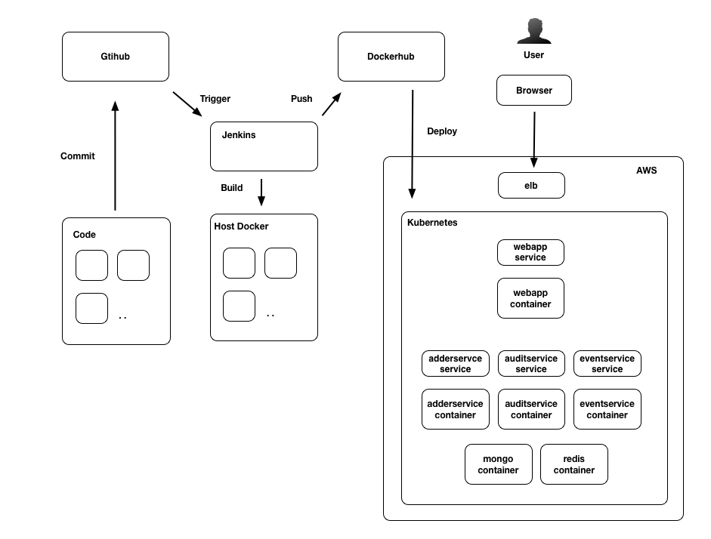

image

Note that the configuration is very similar to our local setup, only that we have now deployed our system to the AWS cloud. Kubernetes is running on three AWS machine instances: one master and two worker nodes. Our containers are distributed across these nodes, in fact we don't event care too much which instances they are running on as Kubernetes manages workload and distribution for us.

The kops tool powerful. It allows us to manage multiple Kubernetes clusters and takes a lot of the grunt work out of so doing. THe kops tool stores its configuration (known as the kops state store) in an S3 bucket so that it's centrally available.

Both 'kops and Kubernetes use the information in the state store to configure and update the cluster and underlying infrastructure. To edit the contents of the state store we should always use the kops interface, rather than editing the files on S3 directly.

For example to edit the cluster information we could run:

$ kops edit cluster

The kops tool uses a set of rules to specify sensible default values for the Kubernetes cluster, hiding a lot of the detailed configuration.

While this is useful to spin up a staging cluster it is advisable to fully understand the configuration at a more detailed level when implementing production grade clusters, particularly with regard to system security.

To view a list of all of the resources that kops created for us by running the delete command without the --yes flag:

$ kops delete cluster <cluster name>

Omitting the --yes flag runs the command in preview mode. This provides a list of all the AWS resources. We can inspect these resources in the AWS control panel. For example in the EC2 panel we can observe that three instances were started, on cluster master and two workers.

In our previous recipes we used NodePort as the service type, this is because minikube does not support the LoadBalancer service type. However in our full Kubernetes cluster this maps onto an AWS ELB which we can again inspect in the EC2 control panel.

Throughout this chapter and **Chapter 10 Building Microservice Systems** we have been working with the same codebase. The codebase has been deployed in development mode using the fuge tool, to a local minikube cluster and now to a full blown Kubernetes cluster on AWS - WITHOUT CHANGE! That is, on the whole, we have not needed to provide separate environment configurations for dev, test, staging and so forth.

This is because the code was developed to use the same service discovery mechanism in all environments. We also harnessed the power of containers not only for deployment but also in development to provide our Mongo and Redis databases.

The kops CLI is just one tool that helps us to automate Kubernetes cluster deployment, others include:

* kube-aws - from the folks at CoreOS, as the name implies targets creating Kubernetes clusters on AWS: https://coreos.com/kubernetes/docs/latest/kubernetes-on-aws-render.html
* Google Container Engine - turnkey cloud based Kubernetes deployment https://cloud.google.com/container-engine/
* Kargo - Supports deployment to bare metal and various cloud providers https://github.com/kubernetes-incubator/kargo

Finally the long form way is to install Kubernetes from scratch: https://kubernetes.io/docs/getting-started-guides/scratch/.

### There's more

Before we delete our cluster from AWS it is worth exploring it a little more, firstly with the Kubernetes dashboard.

#### Running the Dashboard

Recall from our previous use of minikube that we ran the Kubernetes dashboard as a means of inspecting our cluster.

We can install and run the dashboard in our AWS cluster by running the following commands:

$ kubectl create -f https://rawgit.com/kubernetes/dashboard/master/\  
src/deploy/kubernetes-dashboard.yaml  
$ kubectl proxy   
Starting to serve on 127.0.0.1:8001

The proxy command will forward requests on localhost port 3001 to our cluster master on AWS. If we now open a browser at http://localhost:3001/ui/ we can view the Kubernetes dashboard on our cluster as we did with minikube.

#### Inspecting the kops State Store

The kops tool stores its state in our S3 bucket. We can grab the contents of the bucket locally using the AWS tools.

Let's create and enter a fresh directory called store:

$ mkdir store  
$ cd store

Then we can run the following command to pull the State Store to our local machine:

$ aws s3 sync s3://<bucket name> .

This will fetch the entire contents of the kops state store for us to inspect. The directory structure is as follows:

├── addons  
│   └── ...  
├── cluster.spec  
├── config  
├── instancegroup  
│   └── ...  
├── pki  
│   └── ...  
└── secrets  
 └── ...

The key files are cluster.spec and config which control the overall structure of our cluster. Dissecting these configuration files is a great way to take our Kubernetes knowledge to the next level.

Sadly that is beyond the scope of this chapter, and indeed beyond the scope of Node Cookbook. However, we now know how to build, manage, and deploy a distributed Node.js system.

### See also

* *Adding a Queue Based Service* in **Chapter 10 Building Microservice Systems**
* *Service discovery with DNS* in **Chapter 10 Building Microservice Systems**
* *Deploying a Container to Kubernetes* in this chapter
* *Deploying a full system* in this chapter